**USER REQUIREMENT**

**(Bhutan Bio-Security& Food Safety System)**



**Bhutan Agriculture & Food Regulatory Authority**

Contents

1. Food Business Registration and Licensing 14

1.1. Service Name: Food Business Registration and Licensing 14

1.2. Process Flow 14

1.3. Users and Roles 15

1.3.1. Food Business Operator (User) 15

1.3.1.1. FBO Apply (Role) 15

1.3.1.2. FBO Inspection Response (Role) 18

1.3.2. BAFRA HQ (User) 19

1.3.2.1. Forward application (Role) 19

1.3.2.2. Issue license (Role) 19

1.3.3. BAFRA Field Office (User) 19

1.3.3.1. Feasibility Inspection (Role) 19

1.3.3.2. Factory Inspection (Role) 21

2. Clearance for Meat Shop 22

2.1. Service Name: Clearance for meat shop 22

2.2. Process Flow 22

2.3. Users and Roles 23

2.3.1. Meat Shop Operator (User) 23

2.3.1.1. MSO Apply (Role) 23

2.3.1.2. Inspection Response (Role) 24

2.3.2. BAFRA HQ (User) 24

2.3.3. BAFRA Field Office (User) 24

2.3.3.1. Inspection (Role) 24

3. Clearance for Nurseries/Seed Growers 24

3.1. Service Name: Clearance for Nurseries/Seed Growers 24

3.2. Process Flow 24

3.3. Users and Roles 25

3.3.1. Nurseries/ Seed Growers (User) 25

3.3.1.1. NSG Apply (Role) 25

3.3.1.2. Inspection Response (Role) 26

3.3.2. BAFRA HQ (User) 26

3.3.3. BAFRA Field Office (User) 26

3.3.3.1. Inspection (Role) 26

4. Import Food 28

4.1. Service Name: Import Food 28

4.2. Process Flow 28

4.3. Users and Roles 28

4.3.1. Food Importer (User) 28

4.3.1.1. Apply import permit (Role) 28

4.3.1.2. Response for verification (Role) 30

4.3.1.3. Notify consignment arrival date (Role) 30

4.3.2. BAFRA HQ (User) 30

4.3.2.1. Verify/Reject (Role) 30

4.3.2.2. Issue import permit (Role) 31

4.3.3. BAFRA Field Office (User) 31

4.3.3.1. Inspection (Role) 31

5. Import of Livestock product 32

5.1. Service Name: Import of Livestock product 32

5.2. Process Flow 32

5.3. Users and Roles 32

5.3.1. LiveStock Product Importer (User) 32

5.3.1.1. Apply import permit (Role) 32

5.3.1.2. Response for verification (Role) 35

5.3.1.3. Notify consignment arrival date (Role) 35

5.3.2. BAFRA HQ (User) 36

5.3.2.1. Verify/Reject (Role) 36

5.3.2.2. Issue import permit (Role) 36

5.3.3. BAFRA Field Office (User) 36

5.3.3.1. Inspection (Role) 36

6. Import of Live Animal 38

6.1. Service Name: Import of Live Animal 38

6.2. Process Flow 38

6.3. Users and Roles 38

6.3.1. Live Animal Importer (User) 38

6.3.1.1. Apply import permit (Role) 38

6.3.1.2. Response for verification (Role) 41

6.3.1.3. Notify consignment arrival date (Role) 41

6.3.2. BAFRA HQ (User) 42

6.3.2.1. Verify/Reject (Role) 42

6.3.2.2. Issue import permit (Role) 42

6.3.3. BAFRA Field Office (User) 42

6.3.3.1. Inspection (Role) 42

7. Import of Ornamental Fish 44

7.1. Service Name: Ornamental Fish 44

7.2. Process Flow 44

7.3. Users and Roles 44

7.3.1. Ornamental Fish Importer (User) 44

7.3.1.1. Apply import permit (Role) 44

7.3.1.2. Response for verification (Role) 47

7.3.1.3. Notify consignment arrival date (Role) 47

7.3.2. BAFRA HQ (User) 48

7.3.2.1. Verify/Reject (Role) 48

7.3.2.2. Issue import permit (Role) 48

7.3.3. BAFRA Field Office (User) 48

7.3.3.1. Inspection (Role) 48

8. Import permit for plants and Plant products 50

8.1. Service Name: Import permit for plants and Plant products 50

8.2. Process Flow 50

8.3. Users and Roles 50

8.3.1. Plant and plant products Importer (User) 50

8.3.1.1. Apply import permit (Role) 50

8.3.1.2. Response for verification (Role) 53

8.3.1.3. Notify consignment arrival date (Role) 53

8.3.2. BAFRA HQ (User) 53

8.3.2.1. Verify/Reject (Role) 53

8.3.2.2. Issue import permit (Role) 53

8.3.3. BAFRA Field Office (User) 53

8.3.3.1. Inspection (Role) 53

9. Export Certificate for food products 55

9.1. Service Name: Export Certificate for food products 55

9.2. Process Flow 55

9.3. Users and Roles 55

9.3.1. Food Product Exporter (User) 55

9.3.1.1. Apply export permit (Role) 55

9.3.2. BAFRA Field Office (User) 56

9.3.2.1. Inspection (Role) 56

10. Export Certificate for Plant & Plant Products 58

10.1. Service Name: Export Certificate for Plant and Plant products 58

10.2. Process Flow 58

10.3. Users and Roles 58

10.3.1. Plant and plant product Exporter (User) 58

10.3.1.1. Apply export permit (Role) 58

10.3.2. BAFRA Field Office (User) 62

10.3.2.1. Inspection (Role) 62

11. Export Certificate for Live Animal & Animal Products (Health Certificate / Zoo sanitary certificate) 65

11.1. Service Name: Export Certificate for Live Animal and Animal products (Health Certificate / Zoo Sanitary Certificate) 65

11.2. Process Flow 65

11.3. Users and Roles 65

11.3.1. Live Animal and Animal Product Exporter (User) 65

11.3.1.1. Apply export permit (Role) 65

11.3.2. BAFRA Field Office (User) 68

11.3.2.1. Inspection (Role) 68

12. Movement for Plant and Plant products (Seeds/ seedlings /ornamental plants / plants agrochemicals) 70

12.1. Service Name: Movement for Plant and Plant products (Seeds/ seedlings /ornamental plants / plants agrochemicals) 70

12.2. Process Flow 70

12.3. Users and Roles 71

12.3.1. Movement of Plants & Plant Products (User) 71

12.3.1.1. MPO Apply (Role) 71

12.3.2. BAFRA Field Office (User) 72

12.3.2.1. Inspection (Role) 72

13. Movement for Live Animal and Animal product 73

13.1. Service Name: Movement for Animal and Animal Product 73

13.2. Process Flow 73

13.3. Users and Roles 74

13.3.1. Movement of Live Animal and Animal Products (User) 74

13.3.1.1. MLAAP Apply (Role) 74

13.3.2. BAFRA Field Office (User) 75

13.3.2.1. Inspection (Role) 75

14. Licensing of Personnel 77

14.1. Service Name: Licensing of Personnel 77

14.2. Process Flow 77

14.3. Users and Roles 77

14.3.1. Licensing of Personnel (User) 77

14.3.1.1. LoP Apply (Role) 77

14.3.2. BAFRA HQ (User) 79

14.3.3. BAFRA Field Office (User) 79

14.3.3.1. Verify (Role) 79

14.3.3.2. Attendance (Role) 79

15. Good Agricultural Practices 80

15.1. Service Name: Product Certification Services 80

15.2. Process Flow 80

15.3. Users and Roles 80

15.3.1. GAP Certification Applicant (User) 80

15.3.1.1. CA Apply (Role) 80

15.3.1.2. Response to Non-Conformity (Role) 84

15.3.2. BAFRA HQ (User) 84

15.3.2.1. Forward (Role) 84

15.3.2.2. Issue Certificate (Role) 84

15.3.3. BAFRA Audit Team (User) 85

15.3.3.1. Non-Conformity Inspection (Role) 85

15.3.3.2. Re-Response to Non-Conformity (Role) 85

16. Bhutan Organic Certification 86

16.1. Service Name: Bhutan Organic Certification 86

16.2. Process Flow 86

16.3. Users and Roles 86

16.3.1. Bhutan Organic Applicant (User) 86

16.3.1.1. BOA Apply (Role) 86

16.3.1.2. Response to Non-Conformity (Role) 92

16.3.2. BAFRA HQ (User) 92

16.3.2.1. Forward (Role) 92

16.3.2.2. Issue Certificate (Role) 92

16.3.3. BAFRA Audit Team (User) 92

16.3.3.1. Non-Conformity Inspection (Role) 92

16.3.3.2. Re-Response to Non-Conformity (Role) 93

17. Food Product Certification 94

17.1. Service Name: Food Product Certification 94

17.2. Process Flow 94

17.3. Users and Roles 94

17.3.1. Food Product Applicant (User) 94

17.3.1.1. FPA Apply (Role) 94

17.3.1.2. Response to Audit Plan (Role) 97

17.3.1.3. Response to Non-Conformity (Role) 97

17.3.2. BAFRA HQ (User) 98

17.3.2.1. Forward (Role) 98

17.3.2.2. Issue Certificate (Role) 98

17.3.3. BAFRA Audit Team (User) 98

17.3.3.1. Share Audit Plan (Role) 98

17.3.3.2. View Response to Audit Plan (Role) 98

17.3.3.3. Non-Conformity Inspection (Role) 98

17.3.3.4. Re-Response to Non-Conformity (Role) 99

18. Inspection and Monitoring 100

18.1. Service Name: Inspection and Monitoring 100

18.2. Process Flow 100

18.3. Users and Roles 100

18.3.1. BHQ/BFO (User) 100

18.3.1.1. Inspection and monitoring (Role) 100

19. Complain handling 102

19.1. Service Name: Complain handling 102

19.2. Process Flow 102

19.3. Users and Roles 102

19.3.1. Complainant (User) 102

19.3.1.1. Complain (Role) 102

19.3.2. BAFRA Complain handling Officer (User) 103

19.3.2.1. Acknowledge (Role) 103

19.3.2.2. Forward (Role) 103

19.3.3. BAFRA Field Office (User) 103

19.3.4. BAFRA HQ (User) 103

20. Summary of Users and Role 105

21. Detail Roles and user for respective services 109

22.ANNEXURES- FORMATS FOR CERTIFICATE & CLEARANCES **…………………………………………………….**110

# Food Business Registration and Licensing

## Service Name: Food Business Registration and Licensing

## Process Flow

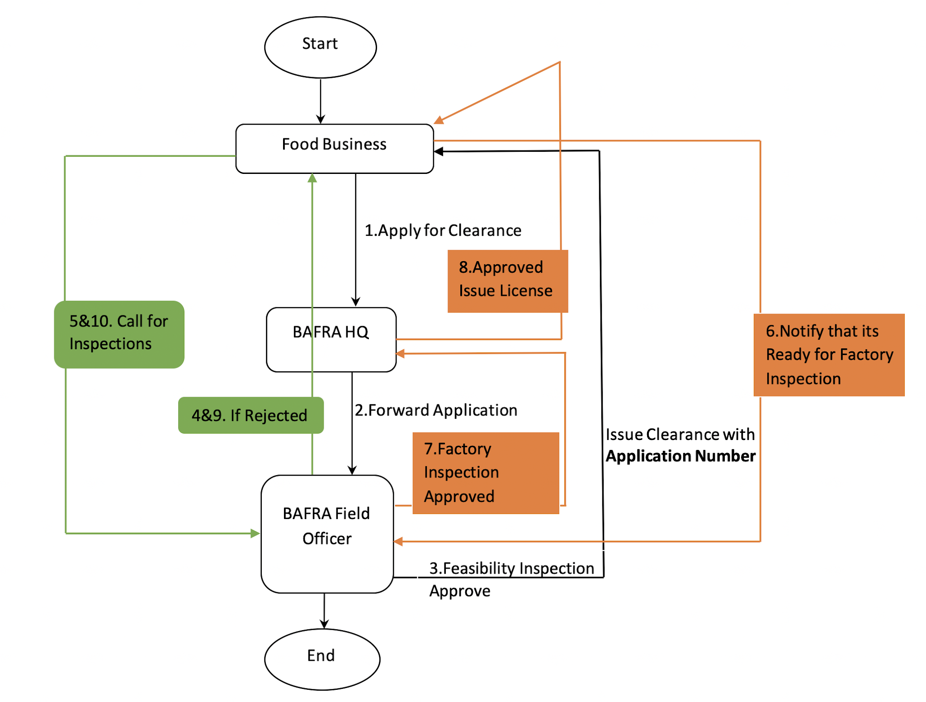

## Users and Roles

## Food Business Operator (User)

## FBO Apply (Role)

|  |  |  |
| --- | --- | --- |
| Field Name | Input Type | Validation |
| Name Of The Food Business | Text |  |
| Address of the FB | Text |  |
| Phone No of the FB | Number | should accept only number, max length 8, should not accept any special character |
| Email of the FB | Email |  |
| Citizenship ID No. of the Owner | Number | Maximum length 11 |
| Name of the Owner |  |  |
| Name of the Top Manager | Text |  |
| Current status of functioning of the FB : | Select | Project stage / Commissioned but regular production yet to start / Regular production in progress |
| Product Category (proposed / being manufactured) | Text area |  |
| Products proposed/being manufactured | Text area |  |
| Identified water source (Pls mention the source) | Text |  |
| Number of years the FB has been in production | Number |  |
| Volume of production during the last calendar year | Number |  |
| Volume Unit | Select | Pull from master table |
| Site history details | Select | Fresh land/Converted structure? |
| If converted, what was the previous business conducted there? | Text area | If converted structure is selected in site history details, enable this text area |
| Any processes outsourced by the FB? | Radio button | Yes and No |
| If yes, please provide details of outsourced processes (refer Table 2: Process Outsource) |  | If Yes enable the Table 2: Process Outsource |
| Name(s) of Authorized Food Handler if already in place | Text | Null able |
| Authorized Food Handlers’ License No | Text | If Authorized food handler is Yes, License no must be specified |
| Legal Entity Status | Select | Private Ltd/Public Ltd /Government undertaking (Pull from master table) |
| Are you a part of a larger Corporation? | Radio button | Yes and No |
| If Yes, indicate relationship with large organization: franchisee, branch, etc. | Text | If Yes enable this form |
| Has the FBO been licensed before? | Radio Button | Yes and No |
| If Yes, provide details of License number | Text | If Yes enable this form |
| Reasons why the License is no longer valid | Text area | Null able |
| Any judicial proceedings relating to the FBOs operations/product? | Radio Button | Yes and No |
| If yes, please provide details | Text area | If Yes enable this form |
| Any proceedings by any Regulatory body or suspension /cancellation /withdrawal of any relevant licensing/approvals under any Regulations | Radio Button | Yes and No |
| If yes, please provide details: | Text area | If Yes enable this form |
| Has a Project Proposal been prepared | Radio Button | Yes and No |
| Upload Files | File | Add more button  (Copy of the Project Proposal including plant layout and details attached) |

Table 2: Process Outsource

|  |  |  |  |  |  |
| --- | --- | --- | --- | --- | --- |
| Sl. No | Processes outsourced | Details FB to whom outsourced | | | |
| Name | Address details | Contact | BAFRA License number |
|  |  |  |  |  |  |
|  |  |  |  | Validation  Should accept only number, Max length 8 | Add more button |

## FBO Inspection Response (Role)

**Details of Concerns:**

|  |  |  |
| --- | --- | --- |
| Field Name | Input Type | Validation |
| Requirement | Display all concern forwarded  Text area | Requirement and clause mapping |
| Clause Number |  |
| Date |  |
| Observations/ Findings |  |
| Response to all concern | Text area |  |
| Response button | Submit |  |
| Notify Button | Submit |  |

** The response of FBO to the concerns can be submitted by clicking “Response Button”

** Upon resolving all the concerns (all concern = No), then enable notify button for factory inspection.

**Response to Non-Conformity:**

|  |  |  |
| --- | --- | --- |
| Field Name | Input Type | Validation |
| Requirement | Display all concern forwarded  Text area | Requirement and clause mapping |
| Clause Number |  |
| Date |  |
| Observations/ Findings |  |
| Response to all non-conformity | Text area |  |
| Response button | Submit |  |

** The response of FBO to the non-conformity can be submitted by clicking “Response Button”

## BAFRA HQ (User)

## Forward application (Role)

** while forwarding the application to the BAFRA Field Office, Acknowledge FBO (refer the annexure1:FSL_acknowledgement_registration.docx).

** Forward application to respective BAFRA Field Office

## Issue license (Role)

Notify FBO and share report with BFO

Download Food Safety License (Annexure 2:FOOD SAFETY LICENSE.docx)

## BAFRA Field Office (User)

## Feasibility Inspection (Role)

Upon clicking the forwarded application (notification) from BHQ, it should display the application form with the following table to input inspection report.

|  |  |  |
| --- | --- | --- |
| Field Name | Input Type | Validation |
| Date of Inspection | Date | Cannot input next day’s date |
| Type of Inspection | Select | Pull from master data (Feasibility) |

Inspection team:(Add more button)

|  |  |  |
| --- | --- | --- |
| Field Name | Input Type | Validation |
| Name |  |  |
| Designation |  |  |

Participants in opening and closing meeting:

|  |  |  |
| --- | --- | --- |
| Field Name | Input Type | Validation |
| Name | Text |  |
| Designation | Text |  |
| Opening date | Date |  |
| Closing date | Date | Cannot be before the opening date and cannot insert the next day date |
| Attended (opening & closing) | Checkbox | Can tick both |

Details of Concerns:

|  |  |  |
| --- | --- | --- |
| Field Name | Input Type | Validation |
| Requirement | Select | Requirement and clause mapping |
| Clause Number | Auto populate based on mapping |  |
| Concern | Radio button | Yes and No |
| Date | date |  |
| Observations/ Findings | Text area |  |

Recommendation:

|  |  |  |
| --- | --- | --- |
| Field Name | Input Type | Validation |
| Recommendation | Text area |  |

** If there are no concern (all radio button above are No), then approve button should be enabled

** If there are concern (any radio button is Yes), then enable reject button

** If approved, then issue clearance with application number (Annexure 3:06. Conditional Food Safety Clearance.docx)

** If rejected, then notify the business operator

** Even if it’s approved detail concerns of feasibility inspection has to be sent to the business operator.

## Factory Inspection (Role)

Upon clicking the forwarded application (notification) from BHQ, it should display the application form with the following table to input inspection report.

|  |  |  |
| --- | --- | --- |
| Field Name | Input Type | Validation |
| Date of Inspection | Date | Cannot input next day’s date |
| Type of Inspection | Select | Pull from master data (Factory) |

Inspection team:

|  |  |  |
| --- | --- | --- |
| Field Name | Input Type | Validation |
| Name | Text |  |
| Designation | Text |  |

Participants in opening and closing meeting:

|  |  |  |
| --- | --- | --- |
| Field Name | Input Type | Validation |
| Name | Text |  |
| Designation | Text |  |
| Opening date | Date |  |
| Closing date | Date | Cannot be before the opening date and cannot insert the next day date |
| Attended (opening & closing) | Checkbox | Can tick both |

Details of Non-Conformities:

|  |  |  |
| --- | --- | --- |
| Field Name | Input Type | Validation |
| Requirement | Select | Requirement and clause mapping |
| Clause Number | Auto populate based on mapping |  |
| NC | Radio button | Yes and No |
| If Yes | Radio Button | if yes Major or Minor |
| Date | date |  |
| Observations/ Findings | Text area |  |

Forward:

|  |  |  |
| --- | --- | --- |
| Field Name | Input Type | Validation |
| Recommendation | Text area |  |

** If there are no NCs (all radio button above are No), then enable (Forward) button for FSL

** If there are NCs (any radio button is Yes), then enable (reject button)

** Forward the application to BHQ for issuance of food safety license by clicking “Forward’ button

** If rejected, then notify the business operator

# Clearance for Meat Shop

## Service Name: Clearance for meat shop

## Process Flow

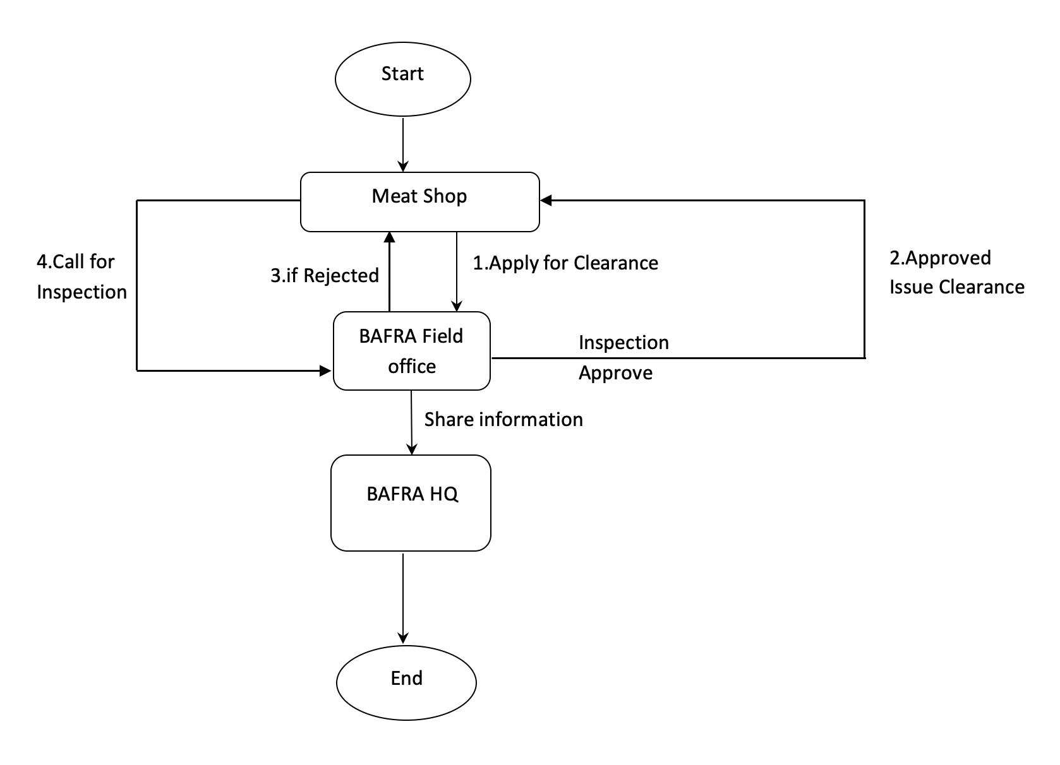

## Users and Roles

## Meat Shop Operator (User)

## MSO Apply (Role)

|  |  |  |
| --- | --- | --- |
| Field Name | Input Type | Validation |
| CID |  | Pull from DCRC |
| Name |  |
| Dzongkhag | Select | Mapping from master data |
| Gewog | Select | Mapping from master data |
| Village | Select | Mapping from master data |
| Email | email |  |
| Contact Number | number | Should accept only a number, max length 8 |
| Upload file | file |  |
| Date | date |  |

** location of the meat shop (dzongkhag, gewog, village)

## Inspection Response (Role)

Call for inspection button

## BAFRA HQ (User)

## BAFRA Field Office (User)

## Inspection (Role)

|  |  |  |
| --- | --- | --- |
| Field Name | Input Type | Validation |
| Date of Inspection | Date | Cannot input next day’s date |
| Type of Inspection | Select | Meat shop inspection |

Inspection team:

|  |  |  |
| --- | --- | --- |
| Field Name | Input Type | Validation |
| Name | Text |  |
| Designation | Text |  |

Details of Observation (add more button):

|  |  |  |
| --- | --- | --- |
| Field Name | Input Type | Validation |
| Observation | Text area |  |
| Action | Text area |  |

** if approved, issue clearance and share information to BHQ (Annexure 3: Clearance for the Establishment of Meat Shop.docx)

** if rejected, notify the MSO

# Clearance for Nurseries/Seed Growers

## Service Name: Clearance for Nurseries/Seed Growers

## Process Flow

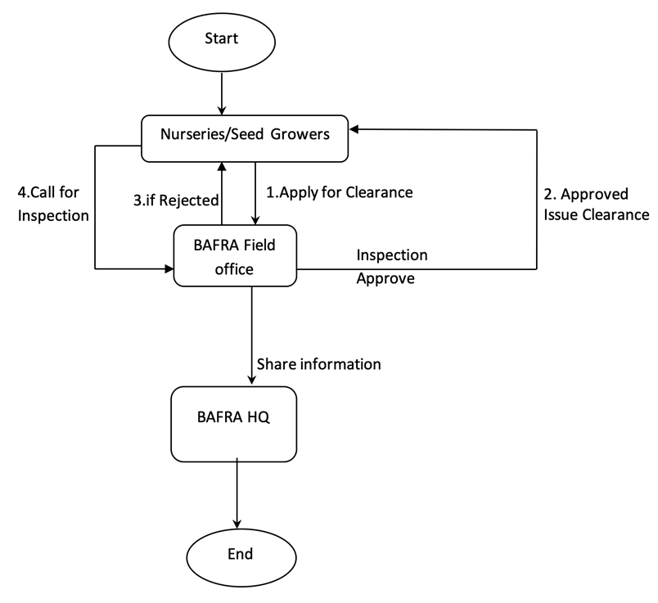

## Users and Roles

## Nurseries/ Seed Growers (User)

## NSG Apply (Role)

|  |  |  |
| --- | --- | --- |
| Field Name | Input Type | Validation |
| Trade License Number |  | Pull from DoT API |
| CID |  |
| Name of the Seed Company or Nurseries |  |
| Name of the Owner |  |
| Contact Number | Number | Max length 8, should accept only number |
| Submitted Date | Date | Today’s date |

Location:

|  |  |  |
| --- | --- | --- |
| Field Name | Input Type | Validation |
| Acreage | Number |  |
| Unit | Pull from master data |  |
| Village | Pull from master data with mapping |  |
| Gewog |  |
| Dzongkhag |  |
|  |  |  |

Type of Nurseries/Seed Growers:

|  |  |  |
| --- | --- | --- |
| Field Name | Input Type | Validation |
| Type of Nurseries/Seed Growers | Select | Bi-annual /Annual/ Perennial |

Plants/Seed (add more button):

|  |  |  |
| --- | --- | --- |
| Field Name | Input Type | Validation |
| Common Name | Text | Mapping of three Fields |
| Scientific Name | Text |
| Variety |  |
| Source of Seed |  |  |
| Quantity | Number |  |
| Remarks |  |  |

## Inspection Response (Role)

Call for inspection button

## BAFRA HQ (User)

## BAFRA Field Office (User)

## Inspection (Role)

|  |  |  |
| --- | --- | --- |
| Field Name | Input Type | Validation |
| Date of Inspection | Date | Cannot input next day’s date |
| Type of Inspection | Select | Pull from master data (Seeds & Nursery) |

Inspection team:

|  |  |  |
| --- | --- | --- |
| Field Name | Input Type | Validation |
| Name |  |  |
| Designation |  |  |

Details of Observation (add more button):

|  |  |  |
| --- | --- | --- |
| Field Name | Input Type | Validation |
| Observation | Text area |  |
| Action | Text area |  |

** if approved, issue clearance and share information to BHQ (Annexure 4: Nursery Registration form/Seed Grower Registration form.pdf)

** if rejected, notify NSG

# Import Food

## Service Name: Import Food

## Process Flow

## 

## Users and Roles

## Food Importer (User)

## Apply import permit (Role)

Individual or Farmers group selection:

|  |  |  |
| --- | --- | --- |
| Field Name | Input Type | Validation |
| CID |  | Pull from DCRC |
| Name |  |
| Dzongkhag |  |
| Gewog |  |
| Village |  |
| Email | email |  |
| Contact No. | Number | Should accept only number, should not accept special character, max length 8 |
| Operation | Radio button | Select from master data |
| Requested duration of permit | Text |  |
| Valid Trade license | Text | Valid with DoT API |

Details of consignment(s){add more }

|  |  |  |
| --- | --- | --- |
| Field Name | Input Type | Validation |
| Food Product Description | textbox |  |
| Quantity | number | Should accept only number, should not accept special character |
| Quantity unit | Select | Select from master data (packaging unit) |
| Type of exporter | checkbox | Producer and/or exporter (if different) |

|  |  |  |
| --- | --- | --- |
| Field Name | Input Type | Validation |
| Label of product | upload |  |
| Country of origin of food | Select | Select from master data (Country list) |
| Country of transit (Where applicable): | Radio button | Yes_no (if yes, mention country) |
| Name of country | Select | Select from master data (Country list) |
| Means of conveyance | Select | (Air, Land, Sea) |
| Place of entry | Select | Select from master data (entry points) |
| Final destination | Select | Select from master data (Dzongkhag) |
| Date | Date |  |
| Submit | Button |  |

GMO condition:

|  |  |  |
| --- | --- | --- |
| Field Name | Input Type | Validation |
| Products are derived from GMO; | Radio button | Yes or No |

*\*\* Upon submitting the form should forward to BHQ*

*\*\* If rejected,*

## Response for verification (Role)

*\*\* If application has been rejected by BHQ, the importer should apply as new application.*

## Notify consignment arrival date (Role)

Notify consignment of arrival date

|  |  |  |
| --- | --- | --- |
| Field Name | Input Type | Validation |
| Import permit no. |  |  |
| Date of arrival | date | Cannot put yesterday’s date |
| Point of arrival | Select | Select from master date |
| Submit | button |  |

Product details (Add more button)

|  |  |  |
| --- | --- | --- |
| Field Name | Input Type | Validation |
| Name of product | text |  |
| Quantity of product | number | Should accept only number, should not accept special character |
| Save | button |  |

*\*\*Upon inserting import permit no. all details according to permit application should be displayed.*

*\*\*submit to BFO*

## BAFRA HQ (User)

## Verify/Reject (Role)

*\*\* Upon clicking the verify button, issue permit and share information to BFO.*

*\*\*Upon clicking the reject button, notify importer*

## Issue import permit (Role)

Refer annexure. 5(Food import Permit)

** While issuing import permit, BAFRA HQ has to assign HSC(Harmonized System Coding) against individual product , HSC and format to be incorporated during the first demonstration of the system.

## BAFRA Field Office (User)

## Inspection (Role)

|  |  |  |
| --- | --- | --- |
| Field Name | Input Type | Validation |
| Name of product | text | Pull from above |
| Quantity requested |  | Pull from above |
| Unit | Select | Pull from master data |
| Quantity cleared | Number | Should accept only number, should not accept special character |
| Unit | Select | Pull from master data |
| Quantity rejected |  | (Qty requested – Qty Cleared) Should accept only number, should not accept special character |
| Unit | Select | Pull from master data |
| Remarks (Reasons for rejection) | Text area |  |

*\*\*If accepted, generate a clearance*

*\*\* If rejected, enable remarks field and save reasons for rejection.*

# Import of Livestock product

## Service Name: Import of Livestock product

## Process Flow

## 

## Users and Roles

## LiveStock Product Importer (User)

## Apply import permit (Role)

Import Type:

|  |  |  |
| --- | --- | --- |
| Field Name | Input Type | Validation |
| Import Type | Select | “Personal” or “Commercial” |

If Personal:

|  |  |  |
| --- | --- | --- |
| Field Name | Input Type | Validation |
| Nationality | Select | “Bhutanese” or “Non-Bhutanese” |

If Bhutanese:

|  |  |  |
| --- | --- | --- |
| Field Name | Input Type | Validation |
| CID |  | Fetch from DCRC |
| Name |  |
| Dzongkhag |  |
| Gewog |  |
| Village |  |

If Non-Bhutanese:

|  |  |  |
| --- | --- | --- |
| Field Name | Input Type | Validation |
| Passport No. | Text |  |
| Nationality | Text |  |
| Name | Text |  |
| Address | Text area |  |

Details of consignment (add more button):

|  |  |  |
| --- | --- | --- |
| Field Name | Input Type | Validation |
| Particulars | Text |  |
| Company / Producers | Text |  |
| Description of the supply /packages | Text area |  |
| Quantity | Number | Should accept only number, should not accept special character |
| Unit | Select | Pull from master data |

Other details:

|  |  |  |
| --- | --- | --- |
| Field Name | Input Type | Validation |
| Purpose of Importation | Text Area |  |
| Origin or source of commodity | Select | From master data |
| Means of conveyance | Select | “Air, Land , Sea” |
| Place of entry | Select | Pull from master data (entry point) |
| Final destination | Select | From dzongkhag master |
| Expected date of arrival | date |  |

** Upon submitting, the form should be forwarded to BHQ

** If rejected, notify applicant

If Commercial :

|  |  |  |
| --- | --- | --- |
| Field Name | Input Type | Validation |
| Nationality | Select | “Bhutanese” or “Foreigner” |

If Bhutanese:

|  |  |  |
| --- | --- | --- |
| Field Name | Input Type | Validation |
| Trade License No. |  | Fetch from DoT |
| Name |  |
| Dzongkhag |  |
| Gewog |  |
| Village |  |

If Foreigner:

|  |  |  |
| --- | --- | --- |
| Field Name | Input Type | Validation |
| Passport No. | Text |  |
| Nationality | Text |  |
| Name | Text |  |
| Address | Text area |  |

Details of consignment (add more button):

|  |  |  |
| --- | --- | --- |
| Field Name | Input Type | Validation |
| Particulars | Text |  |
| Company / Producers | Text |  |
| Description of the supply /packages | Text area |  |
| Quantity | Number | Should accept only number, should not accept special character |
| Unit | Select | Pull from master data |

Other details:

|  |  |  |
| --- | --- | --- |
| Field Name | Input Type | Validation |
| Purpose of Importation | Text Area |  |
| Origin or source of commodity | Select | From master data |
| Means of conveyance | Select | “Air, Land , Sea” |
| Place of entry | Select | Pull from master data (entry point) |
| Final destination | Select | From dzongkhag master |
| Expected date of arrival | date |  |

GMO condition:

|  |  |  |
| --- | --- | --- |
| Field Name | Input Type | Validation |
| Products are derived from GMO; | Radio button | Yes or No |

** Upon submitting, the form should be forwarded to BHQ

** If rejected, notify applicant

## Response for verification (Role)

*\*\* If application has been rejected by BHQ, the importer should apply as new application.*

## Notify consignment arrival date (Role)

Notify consignment of arrival date

|  |  |  |
| --- | --- | --- |
| Field Name | Input Type | Validation |
| Import permit no. | Text |  |
| Date of arrival | date | Cannot put yesterday’s date |
| Point of arrival | Select | pull from master date |
| Submit | button |  |

Product details (Add more button)

|  |  |  |
| --- | --- | --- |
| Field Name | Input Type | Validation |
| Name of product | text |  |
| Quantity of product | number | Should accept only number, should not accept special character |
| Save | button |  |

*\*\*Upon inserting import permit no. all details according to permit application should be displayed.*

*\*\*submit to BFO*

## BAFRA HQ (User)

## Verify/Reject (Role)

** Upon clicking the verify button, issue permit and share information to BFO.

**Upon clicking the reject button, notify importer with remarks

## Issue import permit (Role)

Refer annexure. 6 (LivestockImport Permit)

** While issuing import permit, BAFRA HQ has to assign HSC(Harmonized System Coding) against individual product , HSC and format to be incorporated during the first demonstration of the system.

## BAFRA Field Office (User)

## Inspection (Role)

|  |  |  |
| --- | --- | --- |
| Field Name | Input Type | Validation |
| Name of product | text | Pull from above |
| Quantity requested |  | Pull from above |
| Unit | Select | Pull from master data |
| Quantity cleared | Number | Should accept only number, should not accept special character |
| Unit | Select | Pull from master data |
| Quantity rejected |  | (Qty requested – Qty Cleared) |
| Unit | Select | Pull from master data |
| Remarks (Reasons for rejection) | Text area |  |

*\*\*If accepted, generate a clearance*

*\*\* If rejected, enable remarks field and save reasons for rejection.*

# Import of Live Animal

## Service Name: Import of Live Animal

## Process Flow

## 

## Users and Roles

## Live Animal Importer (User)

## Apply import permit (Role)

Import Type:

|  |  |  |
| --- | --- | --- |
| Field Name | Input Type | Validation |
| Import Type | Select | “Personal” or “Commercial” |

If Personal:

|  |  |  |
| --- | --- | --- |
| Field Name | Input Type | Validation |
| Nationality | Select | “Bhutanese” or “Non-Bhutanese” |

If Bhutanese:

|  |  |  |
| --- | --- | --- |
| Field Name | Input Type | Validation |
| CID |  | Fetch from DCRC |
| Name |  |
| Dzongkhag |  |
| Gewog |  |
| Village |  |

If Non-Bhutanese:

|  |  |  |
| --- | --- | --- |
| Field Name | Input Type | Validation |
| Passport No. | Text |  |
| Nationality | Text |  |
| Name | Text |  |
| Address | Text area |  |

Details of consignment (add more button):

|  |  |  |
| --- | --- | --- |
| Field Name | Input Type | Validation |
| Species | Select | Map and pull from master |
| Breed | Select |
| Age | Number | Should accept only number, should not accept special character |
| Sex | Radio button | Male or Female |
| Number of animal | Number | Should accept only number, should not accept special character |

Other details:

|  |  |  |
| --- | --- | --- |
| Field Name | Input Type | Validation |
| Origin or source of Animal | Select | From master data |
| Means of conveyance | Select | “Air, Land , Sea” |
| Place of entry | Select | Pull from master data (entry point) |
| Final destination | Select | From dzongkhag master |
| Expected date of arrival | date |  |

** Upon submitting, the form should be forwarded to BHQ

** If rejected, notify applicant

If Commercial :

|  |  |  |
| --- | --- | --- |
| Field Name | Input Type | Validation |
| Nationality | Select | “Bhutanese” or “Foreigner” |

If Bhutanese:

|  |  |  |
| --- | --- | --- |
| Field Name | Input Type | Validation |
| Trade License No. |  | Fetch from DoT |
| Name |  |
| Dzongkhag |  |
| Gewog |  |
| Village |  |

If Foreigner:

|  |  |  |
| --- | --- | --- |
| Field Name | Input Type | Validation |
| Passport No. | Text |  |
| Nationality | Text |  |
| Name | Text |  |
| Address | Text area |  |

Details of consignment (add more button):

|  |  |  |
| --- | --- | --- |
| Field Name | Input Type | Validation |
| Species | Select | Map and pull from master |
| Breed | Select |
| Age | Number | Should accept only number, should not accept special character |
| Sex | Radio button | Male or Female |
| Number of animal | Number | Should accept only number, should not accept special character |

Other details:

|  |  |  |
| --- | --- | --- |
| Field Name | Input Type | Validation |
| Origin or source of Animal | Select | From master data |
| Means of conveyance | Select | “Air, Land , Sea” |
| Place of entry | Select | Pull from master data (entry point) |
| Final destination | Select | From dzongkhag master |
| Expected date of arrival | date |  |

GMO condition:

|  |  |  |
| --- | --- | --- |
| Field Name | Input Type | Validation |
| Products are derived from GMO; | Radio button | Yes or No |

** Upon submitting, the form should be forwarded to BHQ

** If rejected, notify applicant

## Response for verification (Role)

*\*\* If application has been rejected by BHQ, the importer should apply as new application.*

## Notify consignment arrival date (Role)

Notify consignment of arrival date

|  |  |  |
| --- | --- | --- |
| Field Name | Input Type | Validation |
| Import permit no. | text |  |
| Date of arrival | date |  |
| Point of arrival | Select | Select from master date |

Animal details (Add more button)

|  |  |  |
| --- | --- | --- |
| Field Name | Input Type | Validation |
| Species | Select | Map and pull from master |
| Breed | Select |
| Age | Number | Should accept only number, should not accept special character |
| Sex | Radio button | Male or Female |
| Number of animal | Number | Should accept only number, should not accept special character |

*\*\*Upon inserting import permit no. all details according to permit application should be displayed.*

*\*\*submit to BFO*

## BAFRA HQ (User)

## Verify/Reject (Role)

** Upon clicking the verify button, issue permit and share information to BFO.

**Upon clicking the reject button, notify importer with remarks

## Issue import permit (Role)

Refer annexure. 7 (Live AnimalImport Permit)

** While issuing import permit, BAFRA HQ has to assign HSC(Harmonized System Coding) against individual product , HSC and format to be incorporated during the first demonstration of the system.

## BAFRA Field Office (User)

## Inspection (Role)

|  |  |  |
| --- | --- | --- |
| Field Name | Input Type | Validation |
| Species | Select | Auto populate |
| Breed | Select | Auto populate |
| Age | Select | Auto populate |
| Sex | Select | Auto populate |
| Quantity requested |  | Pull from above |
| Unit | Select | Pull from master data |
| Quantity cleared | Number | Should accept only number, should not accept special character |
| Unit | Select | Pull from master data |
| Quantity rejected |  | (Qty requested – Qty Cleared) |
| Unit | Select | Pull from master data |
| Remarks (Reasons for rejection) | Text area |  |

*\*\*If accepted, generate a clearance*

*\*\* If rejected, enable remarks field and save reasons for rejection.*

# Import of Ornamental Fish

## Service Name: Ornamental Fish

## Process Flow

## 

## Users and Roles

## Ornamental Fish Importer (User)

## Apply import permit (Role)

Import Type:

|  |  |  |
| --- | --- | --- |
| Field Name | Input Type | Validation |
| Import Type | Select | “Personal” or “Commercial” |

If Personal:

|  |  |  |
| --- | --- | --- |
| Field Name | Input Type | Validation |
| Nationality | Select | “Bhutanese” or “Non-Bhutanese” |

If Bhutanese:

|  |  |  |
| --- | --- | --- |
| Field Name | Input Type | Validation |
| CID |  | Fetch from DCRC |
| Name |  |
| Dzongkhag |  |
| Gewog |  |
| Village |  |

If Non-Bhutanese:

|  |  |  |
| --- | --- | --- |
| Field Name | Input Type | Validation |
| Passport No. | Text |  |
| Nationality | Text |  |
| Name | Text |  |
| Address | Text area |  |

Details of consignment (add more button):

|  |  |  |
| --- | --- | --- |
| Field Name | Input Type | Validation |
| Species | Select | Map and pull from master |
| Quantity | Number | Should accept only number, should not accept special character |
| Quantity Unit | Select | Pull from master data |
| Fishery Source | Text area |  |

Other details:

|  |  |  |
| --- | --- | --- |
| Field Name | Input Type | Validation |
| Purpose of Importation | Text |  |
| Origin or source of Fish | Select | From master data |
| Means of conveyance | Select | “Air, Land , Sea” |
| Place of entry | Select | Pull from master data (entry point) |
| Final destination | Select | From dzongkhag master |
| Expected date of arrival | date |  |

** Upon submitting, the form should be forwarded to BHQ

** If rejected, notify applicant

If Commercial :

|  |  |  |
| --- | --- | --- |
| Field Name | Input Type | Validation |
| Nationality | Select | “Bhutanese” or “Foreigner” |

If Bhutanese:

|  |  |  |
| --- | --- | --- |
| Field Name | Input Type | Validation |
| Trade License No. |  | Fetch from DoT |
| Name |  |
| Dzongkhag |  |
| Gewog |  |
| Village |  |

If Foreigner:

|  |  |  |
| --- | --- | --- |
| Field Name | Input Type | Validation |
| Passport No. | Text |  |
| Nationality | Text |  |
| Name | Text |  |
| Address | Text area |  |

Details of consignment (add more button):

|  |  |  |
| --- | --- | --- |
| Field Name | Input Type | Validation |
| Species | Select | Map and pull from master |
| Quantity | Number | Should accept only number, should not accept special character |
| Quantity Unit | Select | Pull from master data |
| Fishery Source | Text area |  |

Other details:

|  |  |  |
| --- | --- | --- |
| Field Name | Input Type | Validation |
| Purpose of Importation | Text |  |
| Origin or source of Fish | Select | From master data |
| Means of conveyance | Select | “Air, Land , Sea” |
| Place of entry | Select | Pull from master data (entry point) |
| Final destination | Select | From dzongkhag master |
| Expected date of arrival | date |  |

GMO condition:

|  |  |  |
| --- | --- | --- |
| Field Name | Input Type | Validation |
| Products are derived from GMO; | Radio button | Yes or No |

** Upon submitting, the form should be forwarded to BHQ

** If rejected, notify applicant

## Response for verification (Role)

*\*\* If application has been rejected by BHQ, the importer should apply as new application.*

## Notify consignment arrival date (Role)

Notify consignment of arrival date

|  |  |  |
| --- | --- | --- |
| Field Name | Input Type | Validation |
| Import permit no. | text |  |
| Date of arrival | date |  |
| Point of arrival | Select | Select from master date |

Fish details (Add more button)

|  |  |  |
| --- | --- | --- |
| Field Name | Input Type | Validation |
| Species | Select | Map and pull from master |
| Quantity | Number | Should accept only number, should not accept special character |
| Quantity Unit | Select | Pull from master data |
| Fishery Source | Text area |  |

*\*\*Upon inserting import permit no. all details according to permit application should be displayed.*

*\*\*submit to BFO*

## BAFRA HQ (User)

## Verify/Reject (Role)

** Upon clicking the verify button, issue permit and share information to BFO.

**Upon clicking the reject button, notify importer with remarks

## Issue import permit (Role)

Refer annexure. 10 (: Ornamental Fish Import Permit)

** While issuing import permit, BAFRA HQ has to assign HSC(Harmonized System Coding) against individual product , HSC and format to be incorporated during the first demonstration of the system.

## BAFRA Field Office (User)

## Inspection (Role)

|  |  |  |
| --- | --- | --- |
| Field Name | Input Type | Validation |
| Species | Select | Map and pull from master |
| Quantity | Number | Should accept only number, should not accept special character |
| Quantity Unit | Select | Pull from master data |
| Fishery Source | Text area |  |
| Quantity cleared | Number | Should accept only number, should not accept special character |
| Unit | Select | Pull from master data |
| Quantity rejected |  | (Qty requested – Qty Cleared) |
| Unit | Select | Pull from master data |
| Remarks (Reasons for rejection) |  |  |

*\*\*If accepted, generate a clearance*

*\*\* If rejected, enable remarks field and save reasons for rejection.*

# Importpermitforplants and Plant products

## Service Name: Import permit for plants and Plant products

## Process Flow

## 

## Users and Roles

## Plant and plant products Importer (User)

## Apply import permit (Role)

Import Type:

|  |  |  |
| --- | --- | --- |
| Field Name | Input Type | Validation |
| Import Type | Select | “Personal” or “Commercial” |

If Personal:

|  |  |  |
| --- | --- | --- |
| Field Name | Input Type | Validation |
| Nationality | Select | “Bhutanese” or “Non-Bhutanese” |

If Bhutanese:

|  |  |  |
| --- | --- | --- |
| Field Name | Input Type | Validation |
| CID |  | Fetch from DCRC |
| Name |  |
| Dzongkhag |  |
| Gewog |  |
| Village |  |

If Non-Bhutanese:

|  |  |  |
| --- | --- | --- |
| Field Name | Input Type | Validation |
| Passport No. | Text |  |
| Nationality | Text |  |
| Name | Text |  |
| Address | Text area |  |

Choice:

|  |  |  |
| --- | --- | --- |
| Field Name | Input Type | Validation |
| Import option | Select | Import “biological control agents” or “plant and plant products” |

**if import biological control agent, use following table:

Details of consignment (add more button):

|  |  |  |
| --- | --- | --- |
| Field Name | Input Type | Validation |
| Name of Pesticides | Select | Pull from master data |
| Descriptions | Text area |  |
| Quantity | Number | Should accept only number, should not accept special character |
| Unit | Select | Pull from master data |

Other details:

|  |  |  |
| --- | --- | --- |
| Field Name | Input Type | Validation |
| Purpose of Import | Text Area |  |
| Address of supplying agency | Text area |  |
| Place of entry | Select | Pull from master data (entry point) |
| Final destination | Select | From dzongkhag master |
| Expected date of arrival | date | Cannot put yesterday’s date |

**if it is plant or plant products, use the following table:

Details of consignment (add more button):

|  |  |  |
| --- | --- | --- |
| Field Name | Input Type | Validation |
| Common name | Select | from master data |
| Scientific name | Select |
| Variety | Select |
| Quantity | Number | Should accept only number, should not accept special character |
| Unit | select | From Master data |

Other details:

|  |  |  |
| --- | --- | --- |
| Field Name | Input Type | Validation |
| Origin or source of plant | Select | From master data |
| Address of supplying agency | Text area |  |
| Means of conveyance | Select | Master data |
| Purpose of Import | Text Area |  |
| Port of entry | Select | Pull from master data (entry point) |
| Purpose | Text area |  |
| Final destination | Select | From dzongkhag master |
| Expected date of arrival | date |  |

GMO condition:

|  |  |  |
| --- | --- | --- |
| Field Name | Input Type | Validation |
| Products are derived from GMO; | Radio button | Yes or No |

## Response for verification (Role)

*\*\* If application has been rejected by BHQ, the importer should apply as new application.*

## Notify consignment arrival date (Role)

Plant and Plant products details (Add more button)

|  |  |  |
| --- | --- | --- |
| Field Name | Input Type | Validation |
| Name of plant and plant product | text |  |
| Quantity of plant and plant product | number | Should accept only number, should not accept special character |
| Variety | Select | Pull from masters data |
| Quantity | number |  |

**upon submitting, it should notify BFO

## BAFRA HQ (User)

## Verify/Reject (Role)

*\*\* Upon clicking the verify button, issue permit and share information to BFO.*

*\*\*Upon clicking the reject button, notify importer*

## Issue import permit (Role)

Refer annexure. 8 (plant and plant products import permit)

Refer annexure. 9 (Import permit for biological control agent)

## BAFRA Field Office (User)

## Inspection (Role)

|  |  |  |
| --- | --- | --- |
| Field Name | Input Type | Validation |
| Name of plant and plant product |  | Auto populate |
| Quantity of plant and plant product |  |
| Variety |  |
| Quantity cleared | number | Should accept only number, should not accept special character |
| Unit | select | Pull from masters data |
| Quantity rejected | number | Should accept only number, should not accept special character |
| Unit | select | Pull from masters data |
| Remarks | text area |  |

*\*\*If accepted, generate a clearance*

*\*\* If rejected, enable remarks field and save reasons for rejection.*

# Export Certificate for food products

## Service Name: Export Certificate for food products

## Process Flow

## 

## Users and Roles

## Food Product Exporter (User)

## Apply export permit (Role)

Description of consignment:

|  |  |  |
| --- | --- | --- |
| Field Name | Input Type | Validation |
| Trade license | text | Pull from DoT |
| CID |  |
| Name of exporter |  |
| Dzongkhag |  |
| Gewog |  |
| Village |  |
| Name of importer | text |  |
| Address of importer | Textarea |  |
| Number of packages | number | Should accept only number,  should not accept special character |
| Description of packages | text area |  |
| Declared point of exit | Select | Pull from master’s data |
| Name of the product | Text |  |
| Quantity declared | number | Should accept only number,  should not accept special character |
| Tentative date of export | date | Cannot select yesterday’s date |
| Location of Consignment | select | Pull from master data(Origin or source of country) |
| Any Additional Information | textbox |  |
| Inspection Date | date | Cannot select before tentative date of export |
| Purpose for export | select | **sale/further processing** |
| Place of Inspection | text |  |

Do you need GMO:

|  |  |  |
| --- | --- | --- |
| Field Name | Input Type | Validation |
| GMO Free Certificate | Radio button | Yes/No |

Do you need Radiation Certificate :

|  |  |  |
| --- | --- | --- |
| Field Name | Input Type | Validation |
| Radiation Certificate | Radio button | Yes/No |

*\*\* Upon submitting, the form should forward to BHO*

## BAFRA Field Office (User)

## Inspection (Role)

|  |  |  |
| --- | --- | --- |
| Field Name | Input Type | Validation |
| Name of product | Auto populate | Pull from above |
| Quantity requested | Auto populate |
| Unit | Auto populate |
| Quantity certified | Number | Should accept only number,  should not accept special character |
| Unit | Select | Pull from master data |
| Quantity rejected | Number | (requested-certified)Should accept only number,  should not accept special character |
| Unit | Select | Pull from master data |
| Remarks (Reasons for rejection) |  |  |

** if approved, issue certificate and share information to BHQ

**Refer annexure. 11 (Export certificate format)

*\*\*Upon clicking the reject button, notify exporter*

# Export Certificate for Plant & Plant Products

## Service Name: Export Certificate for Plant and Plant products

## Process Flow

## 

## Users and Roles

## Plant and plant product Exporter (User)

## Apply export permit (Role)

Type of Permit:

|  |  |  |
| --- | --- | --- |
| Field Name | Input Type | Validation |
| Type | Select | Pull from master data(Export certificate or Phytosanitory certificate) |

Profile:

|  |  |  |
| --- | --- | --- |
| Field Name | Input Type | Validation |
| CID |  | Pull from DCRT Api |
| Name |  |
| Permanent Address |  |
| Trade License |  |
| Contact no | number | Should not accept any special number, should accept only number |
| Email | email |  |
| Current Address | Text area |  |
| Date of Inspection Requested | date |  |
| Place of Inspection Requested | select | Pull from master data |

If both direct export and retail selected, use the following table:

|  |  |  |
| --- | --- | --- |
| Field Name | Input Type | Validation |
| Type of export | Select | For direct export only or For retail through outlets |

If direct export certificate, use following table :( Add more button)

|  |  |  |
| --- | --- | --- |
| Field Name | Input Type | Validation |
| DAMC Registration |  |  |
| Royalty Slip | Number | Should not accept any special number, should accept only number |
| Product Name | Text |  |
| Gross Weight | Number | Should accept only number,  should not accept special character |
| Gross Weight Unit | Select | Pull from master data |
| Net Weight | Number | Should accept only number,  should not accept special character |
| Net Weight Unit | Select | Pull from master data |
| No. of Package | Number | Should accept only number,  should not accept special character |
| Description of packaging material | Text area |  |
| Declared point of exit | Select | Pull from master data |
| Importing Country | Select | Pull from master data |
| Name of Consignee | Text |  |
| Address of Consignee | Text area |  |
| Name of Conveyance | Text |  |
| Mode of Conveyance | Select | Sea/Air/Road/Rail/Passenger |

Do you need GMO:

|  |  |  |
| --- | --- | --- |
| Field Name | Input Type | Validation |
| GMO Free Certificate | Radio button | Yes/No |

Do you need Radiation Certificate :

|  |  |  |
| --- | --- | --- |
| Field Name | Input Type | Validation |
| Radiation Certificate | Radio button | Yes/No |

If Retail through Outlet certificate is selected, use following table:

|  |  |  |
| --- | --- | --- |
| Field Name | Input Type | Validation |
| Product Name | Text |  |
| Gross Weight | Number | Should accept only number,  should not accept special character |
| Gross Weight Unit | Select | Pull from master data |
| Net Weight | Number | Should accept only number,  should not accept special character |
| Net Weight Unit | Select | Pull from master data |
| No. of Package | Number | Should accept only number,  should not accept special character |
| Description of packaging material | Text area |  |
| Name of outlet | Text |  |
| Tel.no. of the outlet owner | Number | Should accept only number,  should not accept special character |
| Address of outlet | Text area |  |
| Admissible agreement | Text |  |

Declaration:

|  |  |  |
| --- | --- | --- |
| Field Name | Input Type | Validation |
| I/We the exporter/.authorized agent of the exporter declare that the information furnished in this form, to the best of our knowledge and belief, is true, correct and complete in every respect. | Radio Button | Yes/no |
| I/We shall provide any relevant information and related documents connected with export of consignment for issuance of the Export Certificate. | Radio Button |

Do you need GMO:

|  |  |  |
| --- | --- | --- |
| Field Name | Input Type | Validation |
| GMO Free Certificate | Radio button | Yes/No |

*\*\* Upon submitting, the form should forward to BFO*

If phytosanitary is selected, use following table:

|  |  |  |
| --- | --- | --- |
| Field Name | Input Type | Validation |
| CID |  | Pull from DCRC Api |
| Name |  |
| Trade License |  | Cross check with DOT |
| BIC No. | Text |  |
| BCCI No. | Text |  |
| Name of consignee | Text |  |
| Address of consignee | Text area |  |
| Scientific name of Commodity | Select | Pull from master(mapping) |
| Common name of Commodity | select |
| Description of Commodity | Text area |  |
| Quantity(Gross Weight) | Number | Should accept only number,  should not accept special character |
| Unit | Select | Pull from master data |
| Quantity(Net Weight) | Number | Should accept only number,  should not accept special character |
| Unit | Select | Pull from master data |
| Importing Country | Select | Pull from master data |
| Declared point of entry | Select | Pull from master data |
| Number of Package | Number | Should accept only number,  should not accept special character |
| Description of package | Text area |  |
| Distinguishing Marks | Number | Should accept only number,  should not accept special character |
| Purpose/End use | Select | Pull from master data |
| Mode of Conveyance | Select | Pull from master data |
| Name of Conveyance | Text |  |
| Departure Date | Date |  |
| Date of Inspection desired | Date |  |
| Place of Inspection desired | Select | Pull from dzongkhag master data |
| Additional Declaration(required by importing country) | Text |  |
| Pre-application treatment details | Text |  |

Do you need GMO:

|  |  |  |
| --- | --- | --- |
| Field Name | Input Type | Validation |
| GMO Free Certificate | Radio button | Yes/No |

*\*\* Forward the form based on the place of inspection desired to the respective BFO*

## BAFRA Field Office (User)

## Inspection (Role)

|  |  |  |
| --- | --- | --- |
| Field Name | Input Type | Validation |
| Date of Inspection | Date |  |
| No. of Sample drawn | Number | Should not accept special character, should accept only number |
| Total Sample Size | Number | Should not accept special character, should accept only number |
| Sample drawn by | Select | Pull from master data(BARFRA Staff) |
| Sample inspected by | Select | Pull from master data(sample inspector) |

Method of Inspection and Testing

|  |  |  |
| --- | --- | --- |
| Field Name | Input Type | Validation |
| Method of Inspection and Testing | Check box | Pull **all** from master data and display |

Pest Detected:

|  |  |  |
| --- | --- | --- |
| Field Name | Input Type | Validation |
| Pest detected | Radio button | Yes/no |

** if pest detected is **yes**than enable following table:

|  |  |  |
| --- | --- | --- |
| Field Name | Input Type | Validation |
| Pest category | Check box | Insect, Mite, Fungi, Bacteria, Virus, Netmatode, weed |
| Scientific name of pest |  | Enable if pest category is tricked |
| Level of infestation | Check box | High, Medium, Low |
| Live/Dead | Check box | Live or Dead |
| Risk Category | Check box | Quarantine Pest(QP), Regulated Non- Quarantine Pest(RNQP),Non- Quarantine Pest(NQP),  Unknown |

** if **pest category** check box is ticked, enable **scientific name of pest field**

|  |  |  |
| --- | --- | --- |
| Field Name | Input Type | Validation |
| Quarantine /Regulated Non- Quarantine pest | Radio button | Yes/No |
| Comment | Text area | If “Quarantine /Regulated Non- Quarantine pest” is Yes ,enable this field |
| Treatment Possible | Radio button | Yes/No |
| Comment | Text area | If “Treatment Possible” is Yes ,enable this field |
| Laboratory analysis required | Radio button | Yes/No |
| Comment | Text area | If “Laboratory analysis required” is Yes ,enable this field |
| Phytosanitary measures | Radio button | Yes/No |
| Comment | Text area | If “Phytosanitary measures” is Yes ,enable this field |
| Treatment | Radio button | Chemical, Irradiation, Hot Water, Dry Heat, Vapour Heat, Cold treatment |
|  |  |  |

** if **Chemical** in **Treatment Column** is selected in above table, enable the following table:

|  |  |  |
| --- | --- | --- |
| Field Name | Input Type | Validation |
| Chemical Name |  |  |
| Treatment | Radio button | Fumigation, Spray, Seed treatment ,other(specify)  ->if “other” is selected specify field should be enabled |
| Concentration | Text |  |
| Duration | Number | Should not accept special character, should accept only number |
| Unit | Select | Day/hour/min/sec |
| Temperature | Number | Should not accept special character, should accept only number |
| Unit | Select | Degree/Fahrenheit |
| Treated by | text |  |
| Additional Information | Text area |  |
| Date | Date | Today’s date |

** if approved, issue certificate and share information to BHQ

**Refer annexure. 12 (Export certificate)

**Refer annexure. 13 (Phytosanitary format)

*\*\*Upon clicking the reject button, notify exporter*

# Export Certificate for Live Animal & Animal Products (Health Certificate / Zoo sanitary certificate)

## Service Name: Export Certificate for Live Animal and Animal products (Health Certificate / Zoo Sanitary Certificate)

## Process Flow

## 

## Users and Roles

## Live Animal and Animal Product Exporter (User)

## Apply export permit (Role)

Nationality:

|  |  |  |
| --- | --- | --- |
| Field Name | Input Type | Validation |
| Nationality | Select | Pull from master data(Bhutanese or Non-Bhutanese) |

If “**Bhutanses”** is selected in nationality, than enable following table:

Profile:

|  |  |  |
| --- | --- | --- |
| Field Name | Input Type | Validation |
| CID |  | Pull from DCRC Api |
| Name |  |
| Dzongkhag |  |
| Gewog |  |
| Village |  |
| Email | email |  |
| Contact Number | number | Should accept only number, should not accept special character |

If “**Non-bhutanese**” is selected, than enable the following table:

Profile:

|  |  |  |
| --- | --- | --- |
| Field Name | Input Type | Validation |
| Passport NO | Text |  |
| Name | Text |
| Country | Text |
| Email | email |  |
| Contact Number | number | Should accept only number, should not accept special character |

Type of Permit:

|  |  |  |
| --- | --- | --- |
| Field Name | Input Type | Validation |
| Type | Select | Pull from master data(Live Animal or Animal Product) |

if “**Live Animal**” is selected in Type of Permit, than enable the following table:

No. and Identification of the animals:(Add more button)

|  |  |  |
| --- | --- | --- |
| Field Name | Input Type | Validation |
| Species | Select | Pull from master data(mapping) |
| Breed | Select |
| Age | Number | Should not accept any special character, should accept only number |
| Sex | Radio button | Male or Female |
| Identification NO | Number | Nullable |
| Number of animals | Number | Should not accept any special character, should accept only number |
| Field Name | Input Type | Validation |
| Purpose of Export | Text area |  |
| Premises of Origin of the animal | Text |  |
| Name of Consignee | Text |  |
| Address of Consignee of the importing country | Text area |  |
| Final destination | Text |  |
| Expected date of export | Date | Cannot put yesterday day, should be after 2weeks from today’s date |
| Date | Date | Today’s Date |

Do you need GMO:

|  |  |  |
| --- | --- | --- |
| Field Name | Input Type | Validation |
| GMO Free Certificate | Radio button | Yes/No |

if “ **Animal Product**” is selected in Type of Permit, than enable the following table:

Details of consignment:(Add more button)

|  |  |  |
| --- | --- | --- |
| Field Name | Input Type | Validation |
| Particulars | text |  |
| Company/Producer | text |  |
| Description of supply/package | Text area |  |
| Quantity | number | Should not accept any special character, should accept only number |
| Quantity Unit | Select | Pull from the master data |

|  |  |  |
| --- | --- | --- |
| Field Name | Input Type | Validation |
| Heat Treated | Radio button | Yes/No |
| Purpose of Export | Text area |  |
| Source of commodity | Select | Pull from master data |
| Name of Consignee | Text |  |
| Address of Consignee of the importing country | Text area |  |
| Final destination | Select | Pull from master data(destination) |
| Expected date of arrival | date | Cannot put yesterday day |
| Date | Date | Today’s date |

Do you need GMO:

|  |  |  |
| --- | --- | --- |
| Field Name | Input Type | Validation |
| GMO Free Certificate | Radio button | Yes/No |

*\*\* forward the form based on the place of inspection desired to the respective BFO*

## BAFRA Field Office (User)

## Inspection (Role)

For Live Animal:

|  |  |  |
| --- | --- | --- |
| Field Name | Input Type | Validation |
| Species |  | Auto Populate |
| Breed |  |
| Age |  |
| Sex |  |
| Identification NO |  |
| Requested Number of animals |  |
| Number of Animal Cleared | Number | Should not accept any special character, should accept only number |
| Number of Rejected | Number | Requested-cleared(readonly)Should accept only number,  should not accept special character |
| Remarks(Reason for rejection) |  | Enable this field only if there is **animal rejected** |

For Animal Product:

|  |  |  |
| --- | --- | --- |
| Field Name | Input Type | Validation |
| Description of supply/package |  | Auto Populate |
| Requested Quantity |  |
| Quantity Unit |  |
| Quantity Cleared | Number | Should not accept any special character, should accept only number |
| Quantity Unit | Select | Pull from master data |
| Quantity Rejected | Number | Requested- cleared(readonly)Should accept only number,  should not accept special character |
| Quantity Unit | Select | Pull from master data |
| Remarks(Reason for Rejection) |  | Enable this field only if there is Quantity rejected |

** if approved, issue certificate and share information to BHQ

**Refer annexure. 14 (Health certificate)

**Refer annexure. 15 (Zoo sanitary format)

*\*\*Upon clicking the reject button, notify exporter*

# Movement for Plant and Plant products (Seeds/ seedlings /ornamental plants / plants agrochemicals)

## Service Name: Movement for Plant and Plant products (Seeds/ seedlings /ornamental plants / plants agrochemicals)

## Process Flow

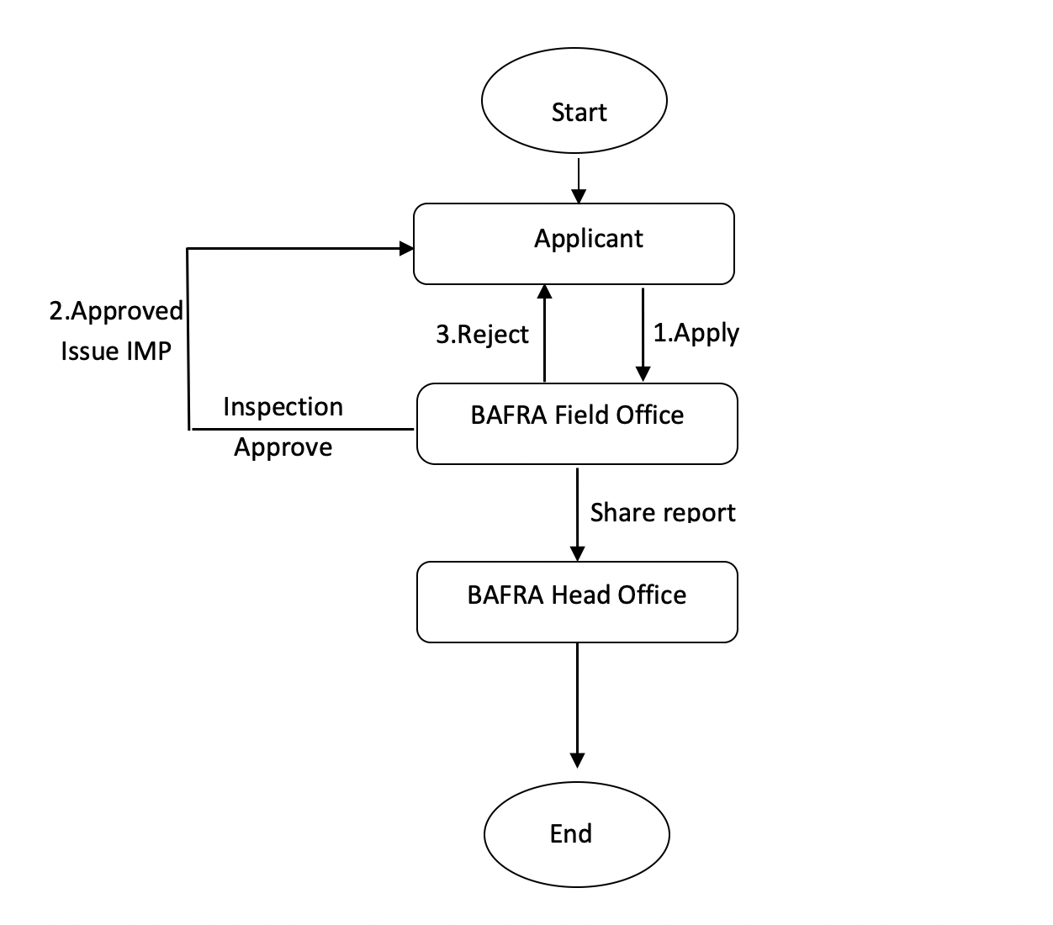

## Users and Roles

## Movement of Plants & Plant Products (User)

## MPO Apply (Role)

(Add more button)

|  |  |  |
| --- | --- | --- |
| Field Name | Input Type | Validation |
| Common name | Select | Pull from master data (Annexure 8) |
| Scientific name | select |
| Variety | select |
| Quantity | number | Should accept only number,  should not accept special character |
| Unit | Select | Pull from master data |

|  |  |  |
| --- | --- | --- |
| Field Name | Input Type | Validation |
| CID |  | Pull from DCRC |
| Name |  |
| Dzongkhag |  |
| Gewog |  |
| Village |  |
| Reason for movement | Textarea |  |
| Source/Origin of Product | text |  |
| Movement from Dzongkhag | select | Pull from master data |
| Movement from Gewog | select |
| Movement from place name | text |  |
| Movement to Dzongkhag | select | Pull from master data |
| Movement to Gewog | select |
| Movement to Place name | text |  |
| Route | text |  |
| Means of travel | select | Select from master data |
| Vehicle no | text |  |
| Date of Journey | date | Cannot select yesterday’s date |
| Date of arrival | date | Cannot select before date of journey |
| Date | date | Data entry date |

## BAFRA Field Office (User)

## Inspection (Role)

|  |  |  |
| --- | --- | --- |
| Field Name | Input Type | Validation |
| Date of Inspection | Date | today’s date |
| Type of Inspection | Select | Pull from master data |

Inspection team (add more button):

|  |  |  |
| --- | --- | --- |
| Field Name | Input Type | Validation |
| Name | Text |  |
| Designation | Text |  |

Recommendation;

|  |  |  |
| --- | --- | --- |
| Field Name | Input Type | Validation |
| Planting materials |  | Auto populate |
| Variety |  |
| Quantity requested |  |
| Quantity Certified | Number | Cannot be more than requested quantity |
| Unit | Select | Pull from master |
| Quantity Certified Value | number | Should accept only number,  should not accept special character |
| Quantity rejected | number | (Quantity certified – Quantity rejected)Should accept only number,  should not accept special character |
| Quantity rejected value | number | Should accept only number,  should not accept special character |
| Remarks | Text area | Reason for rejection |

** If approved, issue movement permit(refer annexure 16:Movement permit for plant and plant product and share the information to BHQ)

** If rejected, notify applicant.

**if movement permit issued, the permit should be viewable or searchable by all the BFO.

# Movement for Live Animal and Animal product

## Service Name: Movement for Animal and Animal Product

## Process Flow



## Users and Roles

## Movement of Live Animal and Animal Products (User)

## MLAAP Apply (Role)

|  |  |  |
| --- | --- | --- |
| Field Name | Input Type | Validation |
| CID |  | Pull from DCRC |
| Name |  |
| Dzongkhag |  |
| Gewog |  |
| Village |  |
| Reason for movement | Textarea |  |
| Source/Origin of Product | text |  |
| Movement from Dzongkhag | select | Pull from master data |
| Movement from Gewog | select |
| Movement from place name | text |  |
| Movement to Dzongkhag | select | Pull from master data |
| Movement to Gewog | select |
| Movement to Place name | text |  |
| Route | text |  |
| Means of travel | select | Select from master data |
| Vehicle no | text |  |
| Date of Journey | date | Cannot select yesterday’s date |
| Date of arrival | date | Cannot select before date of journey |
| Date | date | Data entry date |

Choice:

|  |  |  |
| --- | --- | --- |
| Field Name | Input Type | Validation |
| Type of movement | Select | Live Animal or Animal products |

If “Live animal” is selected enable the table below (Add more button):

|  |  |  |
| --- | --- | --- |
| Field Name | Input Type | Validation |
| Common name | Select | Pull from master data |
| Scientific name | select |
| Age | Number |  |
| No. of Animal | number |  |
| File Upload | Upload |  |

If “Animal products” is selected enable the table below (Add more button):

|  |  |  |
| --- | --- | --- |
| Field Name | Input Type | Validation |
| Particulars |  | Pull from master data |
| Manufacturer/Producer | Text |
| Quantity | Number |  |
| Quantity Unit | Select | From master data |
| File Upload | Upload |  |

## BAFRA Field Office (User)

## Inspection (Role)

|  |  |  |
| --- | --- | --- |
| Field Name | Input Type | Validation |
| Date of Inspection | Date | today’s date |
| Type of Inspection | Select | Pull from master data |

Recommendation;

|  |  |  |
| --- | --- | --- |
| Field Name | Input Type | Validation |
| Common name |  | Auto populate |
| Scientific name |  |
| Quantity requested |  |
| Quantity Certified | Number | Cannot be more than requested quantity |
| Unit | Select | Pull from master |
| Quantity Certified Value | number | Should accept only number,  should not accept special character |
| Quantity rejected | number | (Quantity certified – Quantity rejected)Should accept only number,  should not accept special character |
| Quantity rejected value | number | Should accept only number,  should not accept special character |
| Remarks | Text area | Reason for rejection |

** If approved, issue movement permit(refer annexure 17: Movement permit for Live Animal and share the information to BHQ)

** If approved, issue movement permit(refer annexure 18: Movement permit for Livestock Products and share the information to BHQ)

** If rejected, notify applicant.

**if movement permit issued, the permit should be viewable or searchable by all the BFO.

# Licensing of Personnel

## Service Name: Licensing of Personnel

## Process Flow

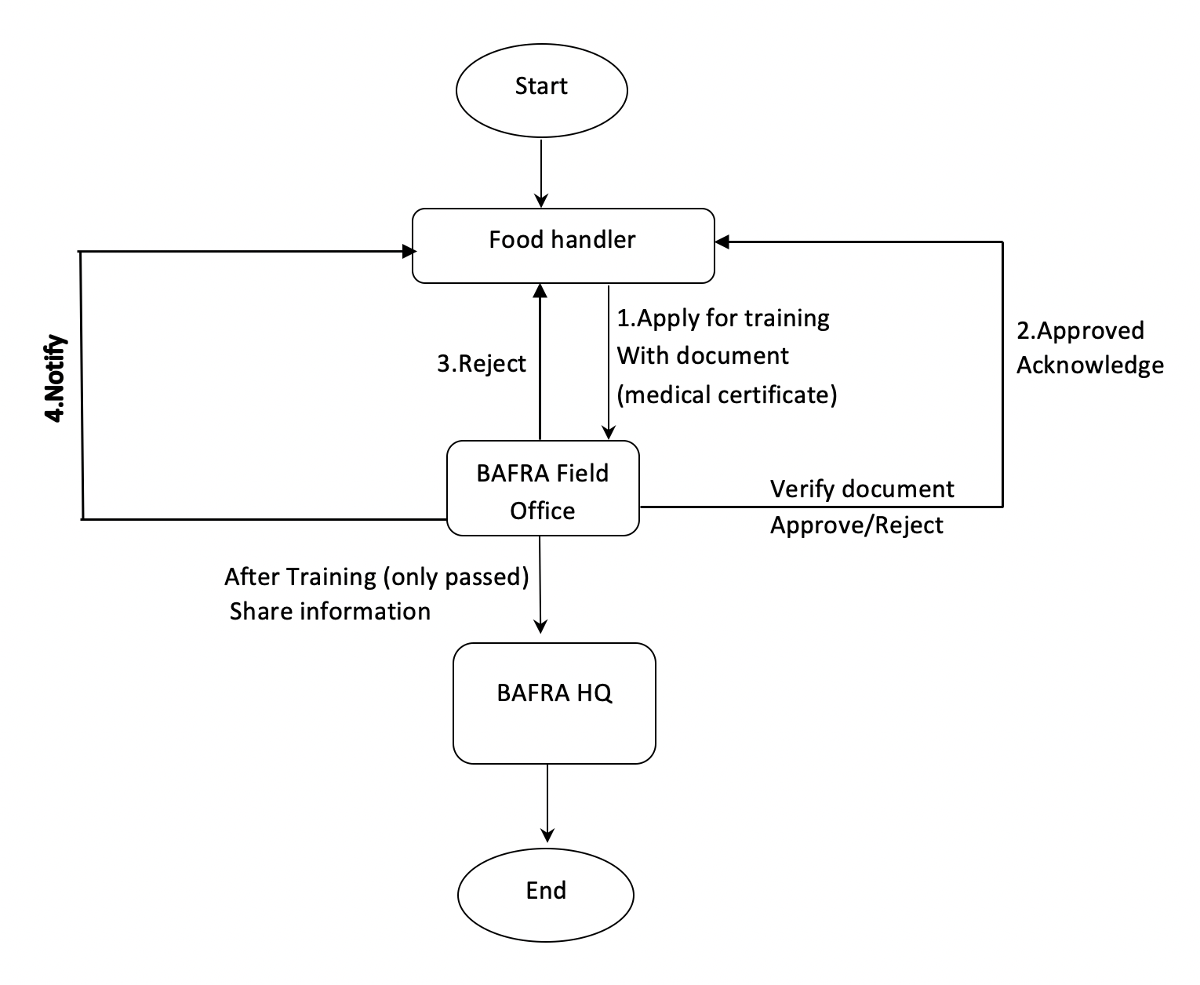

## Users and Roles

## Licensing of Personnel (User)

## LoP Apply (Role)

Nationality selection:

|  |  |  |
| --- | --- | --- |
| Field Name | Input Type | Validation |
| Nationality | Select | Bhutanese or Foreigner |

For Bhutanese:

|  |  |  |
| --- | --- | --- |
| Field Name | Input Type | Validation |
| CID |  | Pull from DCRC API |
| Name |  |
| Dzongkhag |  |
| Gewog |  |
| Village |  |
| Email | Email |  |
| Contact Number | number | Accept only number, max length 8,Should accept only number,  should not accept special character |
| Training Request | Radio Button | Renewal of License or New license |
| Preferred place |  | Pull from master data(BAFRA office list:Annexure 6) |
| Preferred date | Select | Mapping with place (list of training date) |
| Associated food establishment | Text | Null able |
| Upload file | File |  |

** Unless applicant agrees to the Medical Declaration, disable the submit button

For Foreigner:

|  |  |  |
| --- | --- | --- |
| Field Name | Input Type | Validation |
| Permit No. | Text |  |
| Name | Text |
| Country | Text |
| Contact Number | number | Accept only number, max length 8,Should accept only number,  should not accept special character |
| Training Request | Radio Button | Renewal of License or New license |
| Preferred place |  | Pull from master data(BAFRA office list:Annexure 6) |
| Preferred date | Select | Mapping with place (list of training date) |
| Associated food establishment | Text | Null able |
| Upload file | File |  |

** Unless applicant agrees to the Medical Declaration, disable the submit button

## BAFRA HQ (User)

## BAFRA Field Office (User)

## Verify (Role)

** If Approved send acknowledgement to Food handler

** If rejected, enable the remarks field, to provide the reason for rejection, and send to food handler

## Attendance (Role)

** list allthe approved applicant

|  |  |  |
| --- | --- | --- |
| Field Name | Input Type | Validation |
| Permit No/CID | Text |  |
| Name | Text |
| Country | Text |
| Contact Number | number | Accept only number, max length 8,Should accept only number,  should not accept special character |
| Email | Email |  |
| Absent /Present | Select | Absent or present |
| Marks obtained | Number | Criteria set at master data |
| Pass / Fail | Auto |  |

** if absent, disable the mark obtained, and Pass/Fail status

** Notify applicant (pass/fail) while submitting and share it to BHQ

** Both BHQ and BFO can print (license format: Annexure 20)

# Good Agricultural Practices

## Service Name: Product Certification Services

## Process Flow

## Screen Shot 2020-10-10 at 2

## Users and Roles

## GAP Certification Applicant (User)

## CA Apply (Role)

Individual or Farmers group selection:

|  |  |  |
| --- | --- | --- |
| Field Name | Input Type | Validation |
| Type | Select | Individual of Farmers Group |

Individual Farmer:

|  |  |  |
| --- | --- | --- |
| Field Name | Input Type | Validation |
| CID | Number | Pull from DCRC API |
| Name of the farmer |  |
| Dzongkhag |  |
| Gewog |  |
| Village |  |
| Location of the Farm | Text |  |
| Email | Email |  |
| Mobile Number | Number | Accept only number, Max 8 digit,Should accept only number,  should not accept special character |
| Date | date |  |

Farmers Group:

|  |  |  |
| --- | --- | --- |
| Field Name | Input Type | Validation |
| Farmers Group Number | Text |  |
| Farmers Group Name | Text |  |
| Dzongkhag |  | Pull from master |
| Gewog |  |
| Village |  |
| Email | Email |  |
| Mobile Number | Number | Accept only number, Max 8 digit,Should accept only number, should not accept special character |
| Date | Date |  |

** Location of the farm (Dzongkhag, Gewog, Village) to be in label

Farmers Group members (add more button):

|  |  |  |
| --- | --- | --- |
| Field Name | Input Type | Validation |
| CID | Text | Pull from DCRC |
| Name | Text |

For Crop production (add more button):

|  |  |  |
| --- | --- | --- |
| Field Name | Input Type | Validation |
| Name of the crop | Text |  |
| Cultivated Area | Number | Should accept only number, should not accept special character |
| Area Unit | Select | Pull from master data (Acres /Decimal) |
| For the previous year (From date) | date |  |
| For the previous year (To date) | date |  |
| Yield | Number | Should accept only number, should not accept special character |
| Yield Unit | Select | From master data (kg,Mt) |
| Harvest Month | Month | Harvest month should be in between “From” and “To” date |
| Sold | Number | Sold should not be more than yield ,Should accept only number, should not accept special character |
| Sold Unit | Select | From master data (kg,MT) |
| Balance Stock | Number | (Yield – sold ) , should be read only |
| Balance stock unit | select | From master data |
| For the current year (From date) | date |  |
| For the Current year (To date) | date |  |
| Estimated Yield | Number | Should accept only number, should not accept special character |
| Yield Unit | Select | From master data (kg,MT) |
| Estimated Harvest Month | Month | Harvest month should be in between “From” and “To” date |

For Pack House (add more button):

** If Pack house option is selected “Yes” enable the table below;

|  |  |  |
| --- | --- | --- |
| Field Name | Input Type | Validation |
| Name | Text |  |
| Address of the pack house | Text area |  |
| For the previous year (From date) | date |  |
| For the previous year (To date) | date |  |
| Production | Number | Should accept only number, should not accept special character |
| Production Unit | Select | From master data (kg,Mt) |
| Sold | Number | Sold should not be more than yield ,Should accept only number, should not accept special character |
| Sold Unit | Select | From master data (kg,MT) |
| Balance Stock | Number | (Production – sold ) , should be read only, |
| Balance stock unit | select | From master data |
| For the current year (From date) | date |  |
| For the Current year (To date) | date |  |
| Production | Number | Should accept only number, should not accept special character |
| Production Unit | Select | From the master data |
| Sold | Number | Should accept only number, should not accept special character |
| Sold unit | Select | From the master data |
| Balance stock | Number | Should accept only number, should not accept special character |
| Balance stock unit | Select | From the master data |

Standard(s) for which we wish to be certified (check box):

|  |  |  |
| --- | --- | --- |
| Field Name | Input Type | Validation |
| Standard(s) for which we wish to be certified | Text |  |
| With a view to ensure the similarity of the process of production of the mentioned commodities as per related standard, we shall keep regular records and maintain all required documentation to fulfill the requirements of the identified Standard (refer previous point) and any other additional documentation required by the BAFRA as the Certification Body. | Radio button | Agree / Disagree |
| We are willing to change our operational practices, as may be required from time to time to keep in line with our policy which may be directed by BAFRA. | Radio button | Agree / Disagree |
| If BAFRA desires to make a preliminary inspection or investigation then, we, agree to give all our reasonable opportunity and privileges to BAFRA and accordingly provide our cooperation as per certification requirements. | Radio button | Agree / Disagree |
| If the certificate is awarded, We will abide by all the terms and conditions of the certification, so long as it remains valid for use and also comply with the Rules and Regulations. If the license becomes prolonged or it is cancelled, then We, shall ensure that any use of the Standard Mark on any commodity under the license will be stopped immediately and all related advertisement, materials will be taken back and other necessary action will be taken. | Radio button | Agree / Disagree |
| Completed questionnaire for factory assessment | Upload option |  |
| Dear Sir/Madam,  I/we hereby submit an application along with the filled questionnaire, requesting for certification under BAFRA product certification scheme. | Radio Button | Submit |

** There should be an option to download Questionnaire Form (linked to a website)

** There should be an option to upload a filled Questionnaire Form (compulsory - only if uploaded, submit click should work)

## Response to Audit Plan (Role)

|  |  |  |
| --- | --- | --- |
| Field Name | Input Type | Validation |
| Agree/Disagree to Audit plan | Radio button | Agree or Disagree |
| Remarks (can propose new date) | Text area | Enable this field only if “Agree/Disagree to Audit plan” is **Disagreed.** |
| Date | Date | Today’s Date |

** if agree/disagree, notify the BARFA Audit Team

## Response to Non-Conformity (Role)

Response (show non-conformity report forwarded by audit team in the following format);

|  |  |  |
| --- | --- | --- |
| Field Name | Input Type | Validation |
| Audit Criteria | Text area | Auto pull |
| Clause Number | Text area |
| Nonconformity Category | Select |
| Sl.no | Auto number | Auto pull |
| Description of nonconformity | Text area | Auto pull |
| Date | date |  |
| Corrective action proposed by Auditee | Text area |  |
| Corrective action taken by Auditee | Text area | Option for response (by client) and re-response (by BAFRA audit team) |
| Date | date |  |
| Corrective action verified by the auditor | Text area |  |
| Closure of NC | Radio button | Yes and No |
| Date | date |  |

## BAFRA HQ (User)

## Acknowledge (Role)

** If accepted, send acknowledgement to the applicant

** If rejected, enable the remarks field (Text), to provide the reason for rejection, and send to applicant.

## Forward (Role)

** Upon clicking the Forward button, forward the application to the audit team (user creation interface should be displayed)

## Issue Certificate (Role)

Notify the applicant and issue certificate

## BAFRA Audit Team (User)

## Share Audit Plan (Role)

**upload the draft audit plan and share with Applicant.

## View Response to Audit Plan (Role)

** view all the response from applicant and Agree/disagree

|  |  |  |
| --- | --- | --- |
| Field Name | Input Type | Validation |
| Agree/Disagree to Proposed Audit plan | Radio button | Agree or Disagree |
| Remarks(can propose new date) | Text area | Enable this field only if “Agree/Disagree to Audit plan” is **Disagreed.** |
| Date | Date | Today’s Date |

**Notify back to Applicant

## Non-Conformity Reporting (Role)

|  |  |  |
| --- | --- | --- |
| Field Name | Input Type | Validation |
| Name of the Applicant | Select | (Preliminary, Periodic, Other MS) |
| Applicant/ Certification License No | Text area |  |
| Nature of audit | Select | (Preliminary visit, Factory audit, Surveillance audit, Recertification audit, Others) |
| Product for certification | Text area |  |
| Audit Team | Text area |  |
| Date of visit | date |  |

Details of Nonconformities (add more button);

|  |  |  |
| --- | --- | --- |
| Field Name | Input Type | Validation |
| Audit Criteria | Text area |  |
| Clause Number | Text area |  |
| Nonconformity | Radio button | Yes and No |
| Nonconformity Category | Select | If yes (Critical/Major/Minor) |
| Sl.no | Auto number |  |
| Description of nonconformity | Text area |  |
| Date | date |  |

|  |  |  |
| --- | --- | --- |
| Field Name | Input Type | Validation |
| Acknowledgement of report copy | Check box |  |
| Discrepancies have been fully explained and understood by the firm |  |  |
| Confirmation of agreed or proposed corrective actions to be made to BAFRA within ____ days. | number | Should accept only number, should not accept special character |
| Sample drawn along with test request to be deposited within ------- days within the laboratory | number | Should accept only number, should not accept special character |
| Submit button | Button |  |

** If rejected, send NC to applicant

** If approved/rejected, shared report with BAFRA Head and Field Office

## Re-Response to Non-Conformity (Role)

** view all the response from applicant and provide response and close NC

Response (show response to non-conformity by applicant in the following format);

|  |  |  |
| --- | --- | --- |
| Field Name | Input Type | Validation |
| Audit Criteria | Text area | Auto pull |
| Clause Number | Text area |
| Nonconformity Category | Select |
| Sl.no | Auto number |
| Description of nonconformity | Text area |
| Corrective action proposed by Auditee | Text area | Auto pull |
| Corrective action taken by Auditee | Text area | Auto pull |
| Date | date | Auto pull |
| Corrective action verified by the auditor | Text area |  |
| Closure of NC | Radio button | Yes and No |
| Date | date |  |

** When the NCs are closed by the auditor, then enable (Forward) button for recommendation.

** When the NCs are not closed by the auditor, then enable re-response by the applicant.

Recommendation (submit this to BAFRA head office):

|  |  |  |
| --- | --- | --- |
| Field Name | Input Type | Validation |
| Recommendation | Text area |  |

## Share Audit Report (Role)

**upload the Audit report and share with Applicant and BAFRA Head office.

# Bhutan Organic Certification

## Service Name: Bhutan Organic Certification

## Process Flow

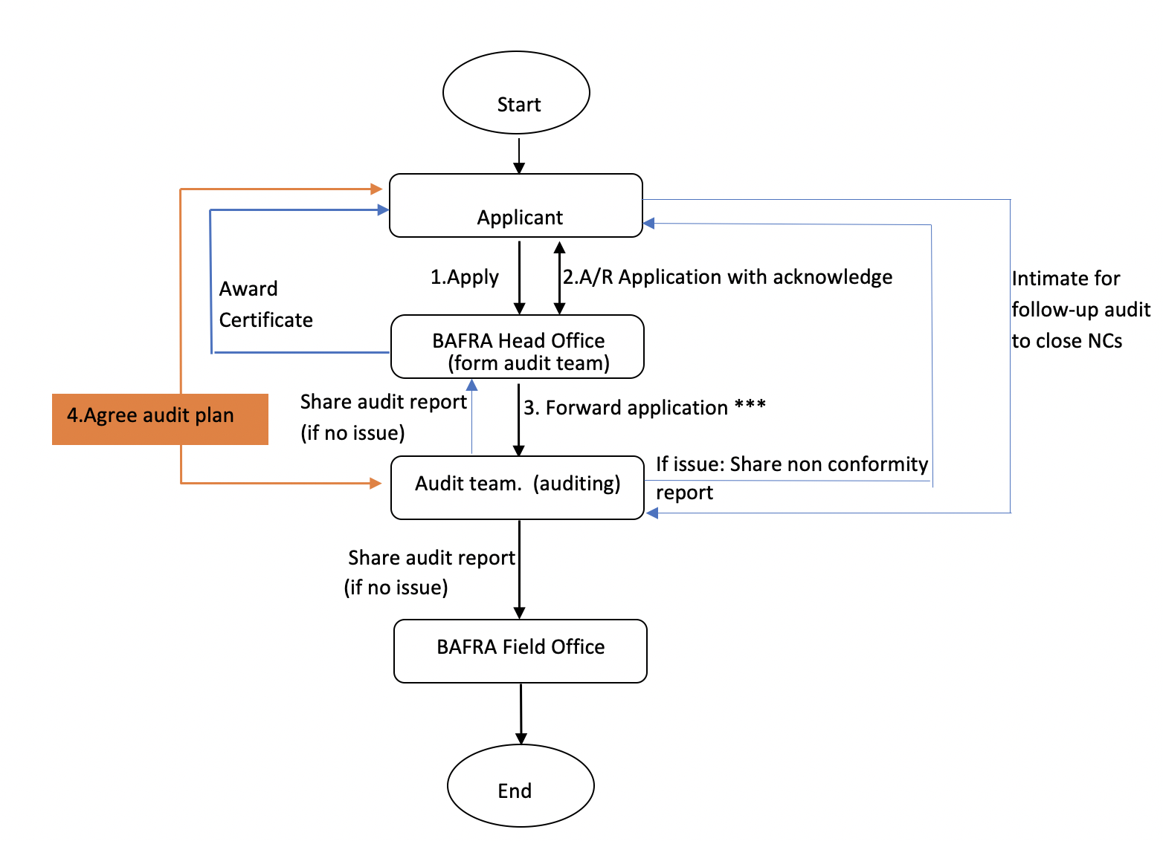

## Users and Roles

## Bhutan Organic Applicant (User)

## BOA Apply (Role)

Individual or Farmers group selection:

|  |  |  |
| --- | --- | --- |
| Field Name | Input Type | Validation |
| Type | Select | Individual of Farmers Group |

Individual farmer:

|  |  |  |
| --- | --- | --- |
| Field Name | Input Type | Validation |
| CID | Number | Pull from DCRC API |
| Name |  |
| Dzongkhag |  |
| Gewog |  |
| Village |  |
| Location of the Farm | Text |  |
| Email | Email |  |
| Mobile Number | Number | Accept only number, Max 8 digit,Should accept only number, should not accept special character |
| Date | date |  |

Farmers Group:

|  |  |  |
| --- | --- | --- |
| Field Name | Input Type | Validation |
| Farmers Group Number | Text |  |
| Farmers Group Name | Text |  |
| Dzongkhag |  | Pull from master |
| Gewog |  |
| Village |  |
| Email | Email |  |
| Mobile Number | Number | Accept only number, Max 8 digit,Should accept only number, should not accept special character |
| Date | Date |  |

** Location of the farm (Dzongkhag, Gewog, Village) to be in label

Farmers Group members (add more button):

|  |  |  |
| --- | --- | --- |
| Field Name | Input Type | Validation |
| CID | Text | Pull from DCRC |
| Name | Text |

For Crop production (add more button):

** If crop production is selected “Yes” enable the table below;

|  |  |  |
| --- | --- | --- |
| Field Name | Input Type | Validation |
| Name of the crop | Text |  |
| Cultivated Area | Number | Should accept only number, should not accept special character |
| Area Unit | Select | Pull from master data (Acres /Decimal) |
| For the previous year (From date) | date |  |
| For the previous year (To date) | date |  |
| Yield | Number | Should accept only number, should not accept special character |
| Yield Unit | Select | From master data (kg,Mt) |
| Harvest Month | Month | Harvest month should be in between “From” and “To” date |
| Sold | Number | Sold should not be more than yield ,Should accept only number, should not accept special character |
| Sold Unit | Select | From master data (kg,MT) |
| Balance Stock | Number | (Yield – sold ) , should be read only |
| Balance stock unit | select | From master data |
| For the current year (From date) | date |  |
| For the Current year (To date) | date |  |
| Estimated Yield | Number | Should accept only number, should not accept special character |
| Yield Unit | Select | From master data (kg,MT) |
| Estimated Harvest Month | Month | Harvest month should be in between “From” and “To” date |

Wild Collection, (add more button):

** If wild collection is selected “Yes” enable the table below;

|  |  |  |
| --- | --- | --- |
| Field Name | Input Type | Validation |
| Common Name | Text |  |
| Botanical Name | Text |  |
| Part of Plant Harvested | Text |  |
| Estimated Harvest Yield | Number | Should accept only number, should not accept special character |
| Estimated Harvest Yield Unit |  | Pull from master |
| Estimated Harvest Yield harvest Season |  | Pull from master |
| Harvest Acreage | Number | Should accept only number, should not accept special character |
| Unit |  | Acre or decimal |

Animal Husbandry (If applicable):

** If animal husbandry is selected “Yes” enable the table below;

|  |  |  |
| --- | --- | --- |
| Field Name | Input Type | Validation |
| Livestock Type | select | Pull from master data |
| Number of male | Number | Should accept only number,  should not accept special character |
| Number of Female | Number | Should accept only number,  should not accept special character |
| Estimated Production | Text |  |
| Estimated Production Unit | Select | Pull from master data |
| Product Sold | text | text |

Aquaculture (If applicable):

** If aquaculture is selected “Yes” enable the table below;

|  |  |  |
| --- | --- | --- |
| Field Name | Input Type | Validation |
| Aquaculture Type | select | Pull from master data |
| Estimated Yield | Number | Should accept only number,  should not accept special character |
| Estimated Yield Unit | Select | Pull from master data |
| Harvest Month | Month |  |
| Sold | Number | Should accept only number,  should not accept special character |
| Sold Unit | Select | Pull from master data |
| Balance Stock |  | Yield – Sold (Read only) |
| Balance Stock Unit | Select | Pull from master data |

Apiculture (If applicable):

** If apiculture is selected “Yes” enable the table below;

|  |  |  |
| --- | --- | --- |
| Field Name | Input Type | Validation |
| Common Name | Text |  |
| Botanical Name | Text |  |
| Estimated Harvest Yield | Number | Should accept only number, should not accept special character |
| Estimated Harvest Yield Unit |  | Pull from master |
| Harvest Acreage | Number | Should accept only number, should not accept special character |
| Unit |  | Acre or decimal |

For Processing Unit, if applicable (add more button):

** If processing is selected “Yes” enable the table below;

|  |  |  |
| --- | --- | --- |
| Field Name | Input Type | Validation |
| Name | Text |  |
| Address of Operation | Text area |  |
| Type of processing | Select | From master data |
| For the previous year (From date) | date |  |
| For the previous year (To date) | date |  |
| Production | Number | Should accept only number, should not accept special character |
| Production Unit | Select | From master data (kg,Mt) |
| Sold | Number | Should accept only number, should not accept special character |
| Sold Unit | Number | Sold should not be more than production,Should accept only number,  should not accept special character |
| Balance Stock | Number | (Production – sold ) , should be read only |
| Balance stock unit | select | From master data |
| For the current year (From date) | date |  |
| For the Current year (To date) | date |  |
| Production | Number | Should accept only number, should not accept special character |
| Production Unit | Select | From master data (kg,Mt) |
| Sold | Number | Sold should not be more than production ,Should accept only number,  should not accept special character |
| Sold Unit | Select | From master data |
| Balance Stock | Number | (Production – sold ) , should be read only |
| Balance stock unit | select | From master data |

Standard(s) for which we wish to be certified (check box):

|  |  |  |
| --- | --- | --- |
| Field Name | Input Type | Validation |
| Standard(s) for which we wish to be certified | Text |  |
| With a view to ensure the similarity of the process of production of the mentioned commodities as per related standard, we shall keep regular records and maintain all required documentation to fulfill the requirements of the identified Standard (refer previous point) and any other additional documentation required by the BAFRA as the Certification Body | Radio button | Agree / Disagree |
| We are willing to change our operational practices, as may be required from time to  time to keep in line with our policy which may be directed by BAFRA. | Radio button | Agree / Disagree |
| If BAFRA desires to make a preliminary inspection or investigation then, we, agree to give all our reasonable opportunity and privileges to BAFRA and accordingly provide our cooperation as per certification requirements. | Radio button | Agree / Disagree |
| If the certificate is awarded, we will abide by all the terms and conditions of the certification, so long as it remains valid for use and also comply with the Rules and Regulations. If the license/certificate becomes prolonged or it is cancelled, then we, shall ensure that any use of the Standard Mark on any commodity under the license will be stopped immediately and all related advertisement, materials will be taken back and other necessary action will be taken | Radio button | Agree / Disagree |
| Completed questionnaire for factory assessment | Upload option*** |  |
| Dear Sir/Madam,  I/we hereby submit an application along with the filled questionnaire, requesting for certification under BAFRA product certification scheme. | Radio Button | Submit |

*** There should be an option to download Questionnaire Form (linked to a website) and there should be an option to upload a filled Questionnaire Form (compulsory - only if uploaded, submit click should work)

## Response to Audit Plan (Role)

|  |  |  |
| --- | --- | --- |
| Field Name | Input Type | Validation |
| Agree/Disagree to Audit plan | Radio button | Agree or Disagree |
| Remarks (can propose new date) | Text area | Enable this field only if “Agree/Disagree to Audit plan” is **Disagreed.** |
| Date | Date | Today’s Date |

** if agree/disagree, notify the BARFA Audit Team

## Response to Non-Conformity (Role)

Response (show non-conformity report forwarded by audit team in the following format);

|  |  |  |
| --- | --- | --- |
| Field Name | Input Type | Validation |
| Audit Criteria | Text area | Auto pull |
| Clause Number | Text area |
| Nonconformity Category | Select |
| Sl.no | Auto number | Auto pull |
| Description of nonconformity | Text area | Auto pull |
| Date | date |  |
| Corrective action proposed by Auditee | Text area |  |
| Corrective action taken by Auditee | Text area | Option for response (by client) and re-response (by BAFRA audit team) |
| Date | date |  |
| Corrective action verified by the auditor | Text area |  |
| Closure of NC | Radio button | Yes and No |
| Date | date |  |

## BAFRA HQ (User)

## Acknowledge (Role)

** If accepted, send acknowledgement to the applicant

** If rejected, enable the remarks field (Text), to provide the reason for rejection, and send to applicant.

## Forward (Role)

** Upon clicking the Forward button, forward the application to the audit team (user creation interface should be displayed)

## Issue Certificate (Role)

Notify the applicant and issue certificate

## BAFRA Audit Team (User)

## Share Audit Plan (Role)

**upload the draft audit plan and share with Applicant.

## View Response to Audit Plan (Role)

** view all the response from applicant and Agree/disagree

|  |  |  |
| --- | --- | --- |
| Field Name | Input Type | Validation |
| Agree/Disagree to Proposed Audit plan | Radio button | Agree or Disagree |
| Remarks(can propose new date) | Text area | Enable this field only if “Agree/Disagree to Audit plan” is **Disagreed.** |
| Date | Date | Today’s Date |

**Notify back to Applicant

## Non-Conformity Reporting (Role)

|  |  |  |
| --- | --- | --- |
| Field Name | Input Type | Validation |
| Name of the Applicant | Select | (Preliminary, Periodic, Other MS) |
| Applicant/ Certification License No | Text area |  |
| Nature of audit | Select | (Preliminary visit, Factory audit, Surveillance audit, Recertification audit, Others) |
| Product for certification | Text area |  |
| Audit Team | Text area |  |
| Date of visit | date |  |

Details of Nonconformities (add more button);

|  |  |  |
| --- | --- | --- |
| Field Name | Input Type | Validation |
| Audit Criteria | Text area |  |
| Clause Number | Text area |  |
| Nonconformity | Radio button | Yes and No |
| Nonconformity Category | Select | If yes (Critical/Major/Minor) |
| Sl.no | Auto number |  |
| Description of nonconformity | Text area |  |
| Date | date |  |

|  |  |  |
| --- | --- | --- |
| Field Name | Input Type | Validation |
| Acknowledgement of report copy | Check box |  |
| Discrepancies have been fully explained and understood by the firm |  |  |
| Confirmation of agreed or proposed corrective actions to be made to BAFRA within ____ days. | number | Should accept only number, should not accept special character |
| Sample drawn along with test request to be deposited within ------- days within the laboratory | number | Should accept only number, should not accept special character |
| Submit button | Button |  |

** If rejected, send NC to applicant

** If approved/rejected, shared report with BAFRA Head and Field Office

## Re-Response to Non-Conformity (Role)

** view all the response from applicant and provide response and close NC

Response (show response to non-conformity by applicant in the following format);

|  |  |  |
| --- | --- | --- |
| Field Name | Input Type | Validation |
| Audit Criteria | Text area | Auto pull |
| Clause Number | Text area |
| Nonconformity Category | Select |
| Sl.no | Auto number |
| Description of nonconformity | Text area |
| Corrective action proposed by Auditee | Text area | Auto pull |
| Corrective action taken by Auditee | Text area | Auto pull |
| Date | date | Auto pull |
| Corrective action verified by the auditor | Text area |  |
| Closure of NC | Radio button | Yes and No |
| Date | date |  |

** When the NCs are closed by the auditor, then enable (Forward) button for recommendation.

** When the NCs are not closed by the auditor, then enable re-response by the applicant.

Recommendation (submit this to BAFRA head office):

|  |  |  |
| --- | --- | --- |
| Field Name | Input Type | Validation |
| Recommendation | Text area |  |

## Share Audit Report (Role)

**upload the Audit report and share with Applicant and BAFRA Head office.

# Food Product Certification

## Service Name: Food Product Certification

## Process Flow



## Users and Roles

## Food Product Applicant (User)

## FPA Apply (Role)

Name of Firm:

|  |  |  |
| --- | --- | --- |
| Field Name | Input Type | Validation |
| Name of the firm |  |  |
| Address: (postal address, city, street name) | Text area |  |
| Telephone | Number | Should accept only number, should not accept special character, |
| Telefax | Number | Should accept only number, should not accept special character |
| Email |  |  |

Factory Address (If different from above):

|  |  |  |
| --- | --- | --- |
| Field Name | Input Type | Validation |
| Name of Factory | Text |  |
| Address: (postal address, city, street name) | Text area |  |
| Telephone | Number | Should accept only number, should not accept special character |
| Telefax | Number | Should accept only number, should not accept special character |

Commodity details:

|  |  |  |
| --- | --- | --- |
| Field Name | Input Type | Validation |
| Brief description of the product | Text area |  |
| Product Trade Mark(s) | Text area |  |

According to my/our best knowledge the quantity of the mentioned commodity/ process and quantity of export and its price is given below:

|  |  |  |
| --- | --- | --- |
| Field Name | Input Type | Validation |
| For the previous year (From date) | date |  |
| For the previous year (To date) | date |  |
| Production | Number | Should accept only number, should not accept special character |
| Production Unit | Select | From master data (kg,Mt) |
| Value | Number | Should accept only number, should not accept special character |
| For the current year (From date) | date |  |
| For the Current year (To date) | date |  |
| Current Year Production | Number | Should accept only number, should not accept special character |
| Current Year Production Unit | Select | From master data (kg,Mt) |
| Value | Number | Should accept only number, should not accept special character |
| For the previous year (From date) | date |  |
| For the previous year (To date) | date |  |
| Export | Number | Should accept only number, should not accept special character |
| Export Unit | Select | From master data (kg,Mt) |
| Export Value | Number | Should accept only number, should not accept special character |
| For the current year (From date) | date |  |
| For the Current year (To date) | date |  |
| Current Year Export | Number | Should accept only number, should not accept special character |
| Current Year Export Unit | Select | From master data (kg,Mt) |
| Value | Number | Should accept only number, should not accept special character |

Standard(s) for which we wish to be certified (check box):

|  |  |  |
| --- | --- | --- |
| Field Name | Input Type | Validation |
| Standard(s) for which we wish to be certified | Text |  |
| With a view to ensure the similarity of the process of production of the mentioned commodities as per related standard, We, shall use the Scheme of Testing and Inspection in our manufacture. We shall keep regular records and maintain all required documentation to fulfill the requirements of the identified Standard (refer previous point) and any other additional documentation required by the BAFRA as the Certification Body. | Radio button | Agree / Disagree |
| We are willing to change our operational practices, as may be required from time to  time to keep in line with our policy which may be directed by BAFRA. | Radio button | Agree / Disagree |
| If BAFRA desires to make a preliminary inspection or investigation then, we, agree to give all our reasonable opportunity and privileges to BAFRA and accordingly provide our cooperation as per certification requirements. | Radio button | Agree / Disagree |
| If the certificate is awarded, We will abide by all the terms and conditions of the certification, so long as it remains valid for use and also comply with the Rules and Regulations. If the license becomes prolonged or it is cancelled, then We, shall ensure that any use of the Standard Mark on any commodity under the license will be stopped immediately and all related advertisement, materials will be taken back and other necessary action will be taken. | Radio button | Agree / Disagree |
| Completed questionnaire for factory assessment | Upload option*** |  |
| Dear Sir/Madam,  I/we hereby submit an application along with the filled questionnaire, requesting for certification under BAFRA product certification scheme. | Radio Button | Submit |

*** There should be an option to download Questionnaire Form (linked to a website) and there should be an option to upload a filled Questionnaire Form (compulsory - only if uploaded, submit click should work)

## Response to Audit Plan (Role)

|  |  |  |
| --- | --- | --- |
| Field Name | Input Type | Validation |
| Agree/Disagree to Audit plan | Radio button | Agree or Disagree |
| Remarks (can propose new date) | Text area | Enable this field only if “Agree/Disagree to Audit plan” is **Disagreed.** |
| Date | Date | Today’s Date |

** if agree/disagree, notify the BARFA Audit Team

## Response to Non-Conformity (Role)

Response (show non-conformity report forwarded by audit team in the following format);

|  |  |  |
| --- | --- | --- |
| Field Name | Input Type | Validation |
| Audit Criteria | Text area | Auto pull |
| Clause Number | Text area |
| Nonconformity Category | Select |
| Sl.no | Auto number | Auto pull |
| Description of nonconformity | Text area | Auto pull |
| Date | date |  |
| Corrective action proposed by Auditee | Text area |  |
| Corrective action taken by Auditee | Text area | Option for response (by client) and re-response (by BAFRA audit team) |
| Date | date |  |
| Corrective action verified by the auditor | Text area |  |
| Closure of NC | Radio button | Yes and No |
| Date | date |  |

## BAFRA HQ (User)

## Acknowledge (Role)

** If accepted, send acknowledgement to the applicant

** If rejected, enable the remarks field (Text), to provide the reason for rejection, and send to applicant.

## Forward (Role)

** Upon clicking the Forward button, forward the application to the audit team (user creation interface should be displayed)

## Issue Certificate (Role)

Notify the applicant and issue Certificate

## BAFRA Audit Team (User)

## Share Audit Plan (Role)

**upload the draft audit plan and share with Applicant.

## View Response to Audit Plan (Role)

** view all the response from applicant and Agree/disagree

|  |  |  |
| --- | --- | --- |
| Field Name | Input Type | Validation |
| Agree/Disagree to Proposed Audit plan | Radio button | Agree or Disagree |
| Remarks(can propose new date) | Text area | Enable this field only if “Agree/Disagree to Audit plan” is **Disagreed.** |
| Date | Date | Today’s Date |

**Notify back to Applicant

## Non-Conformity Reporting (Role)

|  |  |  |
| --- | --- | --- |
| Field Name | Input Type | Validation |
| Name of the Applicant | Select | (Preliminary, Periodic, Other MS) |
| Applicant/ Certification License No | Text area |  |
| Nature of audit | Select | (Preliminary visit, Factory audit, Surveillance audit, Recertification audit, Others) |
| Product for certification | Text area |  |
| Audit Team | Text area |  |
| Date of visit | date |  |

Details of Nonconformities (add more button);

|  |  |  |
| --- | --- | --- |
| Field Name | Input Type | Validation |
| Audit Criteria | Text area |  |
| Clause Number | Text area |  |
| Nonconformity | Radio button | Yes and No |
| Nonconformity Category | Select | If yes (Critical/Major/Minor) |
| Sl.no | Auto number |  |
| Description of nonconformity | Text area |  |
| Date | date |  |

|  |  |  |
| --- | --- | --- |
| Field Name | Input Type | Validation |
| Acknowledgement of report copy | Check box |  |
| Discrepancies have been fully explained and understood by the applicant |  |  |
| Confirmation of agreed or proposed corrective actions to be made to BAFRA within ____ days. | Number | Should accept only number, should not accept special character |
| Sample drawn along with test request to be deposited within ------- days within the laboratory | number | Should accept only number, should not accept special character |
| Submit button | Button |  |

** If rejected, send NC to applicant

** If approved/rejected, shared report with BAFRA Head and Field Office

## Re-Response to Non-Conformity (Role)

** view all the response from applicant and provide response and close NC

Response (show response to non-conformity by applicant in the following format);

|  |  |  |
| --- | --- | --- |
| Field Name | Input Type | Validation |
| Audit Criteria | Text area | Auto pull |
| Clause Number | Text area |
| Nonconformity Category | Select |
| Sl.no | Auto number |
| Description of nonconformity | Text area |
| Corrective action proposed by Auditee | Text area | Auto pull |
| Corrective action taken by Auditee | Text area | Auto pull |
| Date | date | Auto pull |
| Corrective action verified by the auditor | Text area |  |
| Closure of NC | Radio button | Yes and No |
| Date | date |  |

** When the NCs are closed by the auditor, then enable (Forward) button for recommendation.

** When the NCs are not closed by the auditor, then enable re-response by the applicant.

Recommendation (submit this to BAFRA head office):

|  |  |  |
| --- | --- | --- |
| Field Name | Input Type | Validation |
| Recommendation | Text area |  |

## Share Audit Report (Role)

**upload the Audit report and share with Applicant and BAFRA Head office.

# Inspection and Monitoring

## Service Name: Inspection and Monitoring

## Process Flow

** No process flow

## Users and Roles

## BHQ/BFO (User)

## Inspection and monitoring (Role)

**Choice:**

|  |  |  |
| --- | --- | --- |
| Field Name | Input Type | Validation |
| Scope of Inspection | Select | Pull from master data (Scope of Inspection) |

**Profile:**

|  |  |  |
| --- | --- | --- |
| Field Name | Input Type | Validation |
| Name of establishment | Text |  |
| Dzongkhag | Select | Pull from Master data(dzongkhag-gewog-village mapping) |
| Gewog | Select |
| Village | select |
| Phone Number | Number | Should not accept any special character, should accept only number, max length 8 |
| CID of owner | Number | Should not accept any special character, should accept only number, max length 11,Cross check with DCRC Api |

|  |  |  |
| --- | --- | --- |
| Field Name | Input Type | Validation |
| Date of Inspection | Date | Cannot input next day’s date |

Inspection team:(Add more button)

|  |  |  |
| --- | --- | --- |
| Field Name | Input Type | Validation |
| Name |  |  |
| Designation |  |  |

Detail of Inspection Findings:(Add more)

|  |  |  |
| --- | --- | --- |
| Field Name | Input Type | Validation |
| Inspection Criteria | Text area |  |
| Inspection Findings | Text area |  |
| Action proposed by the establishment/firm | Text | Option for response (by client) and re-response (by BAFRA) |

# Complaint handling

## Service Name: Complaint handling

## Process Flow

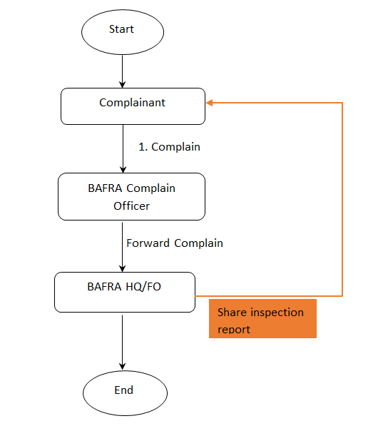

## Users and Roles

## Complainant (User)

## Complaint (Role)

|  |  |  |
| --- | --- | --- |
| Field Name | Input Type | Validation |
| CID |  | Pull from DCRC |
| Name |  |
| Dzongkhag |  |
| Gewog |  |
| Village |  |
| Contact no. | number | Should accept only number, should not accept special character |
| Email ID | email |  |
| Description of Complaint | Textarea |  |
| Date of complaint | text |  |

## BAFRA Complain handling Officer (User)

## Acknowledge (Role)

|  |  |  |
| --- | --- | --- |
| Field Name | Input Type | Validation |
| Acknowledge | button |  |
| Remarks | Textarea | Acknowledgement to complainant(annexure: 23 (**COMPLAINT ACKNOWLEDGEMENT)** |
| Forward | Button | Forward to BHQ/BFO |
| Remarks | Textarea | Forward note |

## 

## Forward (Role)

|  |  |  |
| --- | --- | --- |
| Field Name | Input Type | Validation |
| Forward to BHQ | Select | Pull from masters(BHQ Staff) |
| Forward to BFO | Select | Pull from masters(BFO Staff) |
| Forward | Button | Forward to BHQ/BFO |

## BAFRA Field Office (User)

* + - 1. **Investigation (role)**

** submit report for investigation using inspection role to BHQ

## BAFRA HQ (User)

* + 1. **Inform investigation (role)**

** After investigation, send annexure 24. (**INFORMING CLOSURE OF COMPLAINT)**

* + - 1. **investigation (role)**

** submit report for investigation using inspection role.

# Summary of Users and Role

**Summary of Users and Role**

|  |  |  |
| --- | --- | --- |
| **User** | **Role** | **No of Roles** |
| BHQ A | Verify or Reject (Import Livestock Product)  Verify or Reject (Import Livestock Animal)  Verify or Reject (Import Ornamental fish)  Issue Import Permit (Import Live Animal)  Issue Import Permit (Import Livestock Product)  Issue Import Permit (Import Ornamental fish)  Inspection and Monitoring (Animals)  Complain Investigation (Complain)  Inform Investigation (Complain) | 9 |
| BHQ F | Forward Application (Food Business Registration and Licensing)  Issue License (Food Business Registration and Licensing)  Verify/Reject (Import Food)  Issue Import Permit (Import Food)  Inspection and Monitoring(Food)  Complain Investigation (Complain)  Inform Investigation (Complain) | 7 |
| BHQ P | Verify/Reject (Import Plant and Plant Product)  Issue Import Permit (Import Plant and Plant Product)  Inspection and Monitoring (Plant)  Complain Investigation (Complain)  Inform Investigation (Complain) | 5 |
| BHQ C | Forward (Certification of Food Products)  Forward (Certification of GAP)  Forward (Certification of Bhutan Organic)  Issue Certificate (Certification of Food Products)  Issue Certificate (Certification of GAP)  Issue Certificate (Certification of Bhutan Organic)  Inspection and Monitoring  Complain Investigation (Complain)  Inform Investigation (Complain) | 9 |
| BAT | Share Audit Plan (Certification of Food Products)  Share Audit Plan (Certification of GAP)  Share Audit Plan (Certification of Bhutan Organic)  View responses to Audit Plans (Certification of Food Products)  View responses to Audit Plans (Certification of GAP)  View responses to Audit Plans (Certification of Bhutan Organic)  Non-Conformity (Certification of Food Products)  Non-Conformity (Certification of GAP)  Non-Conformity (Certification of Bhutan Organic)  Re-response to Non-Conformity (Certification of Food Products)  Re-response to Non-Conformity (GAP)  Re-response to Non-Conformity (Certification of Bhutan Organic) | 12 |
| BCHO | Acknowledge (Complain)  Forward (Complain) | 2 |
| BFO | Feasibility Inspection (Food)  Inspection (Meat)  Inspection (NSG)  Inspection (Food Import)  Inspection (Livestock Product Import)  Inspection (Live Animal Import)  Inspection (Plant and Plants Products Import)  Inspection (Ornamental Fish Import)  Inspection (Export Food Products)  Inspection (Export Plant and Plant Products)  Inspection (Export Animal and Animal Products)  Inspection (Incountry Movement Permit of Plants and plants Products )  Inspection (Incountry Movement Permit of Live Animal and Animal Products )  Verify (Licensing of Food Handlers/Meat Handlers)  Attendance (Licensing of Food Handlers/Meat Handlers)  Inspection and Monitoring (Animal)  Inspection and Monitoring (Plant)  Inspection and Monitoring (Food)  Investigation (Complain) | 19 |

# Detail Roles and user for respective services

Detail Roles and user for respective services

Food Business Role

|  |  |  |
| --- | --- | --- |
| FB | Roles | |
| FBO | Apply | Inspection Response |
| BHQF | Forward Application | Issue License |
| BFO | Feasibility Inspection (Food) | X |

|  |  |  |
| --- | --- | --- |
| Meat | Roles | |
| MSO | Apply | Inspection Response |
| BHQ A | X | X |
| BFO | Inspection Meat | X |

|  |  |  |
| --- | --- | --- |
| Nursery | Roles | |
| NSG | Apply | Inspection Response nursery |
| BHQ A | X | X |
| BFO | Inspection NSG | X |

|  |  |  |  |
| --- | --- | --- | --- |
| Import Food | Roles | | |
| Food Importer | Apply | Response for verification | Notify consignment arrival |
| BHQ F | Verify or Reject | Issue Import Permit | X |
| BFO | Inspection Food Import | X | X |

|  |  |  |  |
| --- | --- | --- | --- |
| Import Livestock Product | Roles | | |
| Livestock Product importer | Apply | Response for verification | Notify consignment arrival date |
| BHQ A | Verify or Reject | Issue Import Permit | X |
| BFO | Livestock product import inspection | X | X |

|  |  |  |  |
| --- | --- | --- | --- |
| Import Live Animal | Roles | | |
| Live Animal importer | Apply | Response for verification | Notify consignment arrival date |
| BHQ A | Verify or Reject | Issue Import Permit | X |
| BFO | Live Animal import inspection | X | X |

|  |  |  |  |
| --- | --- | --- | --- |
| Import Plant and Plant Products | Roles | | |
| Plant & Plant Product importer | Apply | Response for verification | Notify consignment arrival date |
| BHQ P | Verify or Reject | Issue Import Permit | X |
| BFO | Plant & Plants product import inspection | X | X |

|  |  |  |  |
| --- | --- | --- | --- |
| Import Ornamental Fish | Roles | | |
| Ornamental Fish Importer | Apply | Response for verification | Notify consignment arrival date |
| BHQ A | Verify or Reject | Issue Import Permit | X |
| BFO | Ornamental Fish import inspection | X | X |

|  |  |  |  |
| --- | --- | --- | --- |
| Export of Food Product | Roles | | |
| Food Product Exporter | Apply | X | X |
| BFO | Export Food Product Inspection | X | X |

|  |  |  |  |
| --- | --- | --- | --- |
| Export of Plant & Plant Products | Roles | | |
| Plant & Plant Product Exporter | Apply | X | X |
| BFO | Export of Plant & Plant Product Inspection | X | X |

|  |  |  |  |
| --- | --- | --- | --- |
| Export of Animal & Animal Products | Roles | | |
| Animal & Animal Product Exporter | Apply | X | X |
| BFO | Export of Animal & Animal Product Inspection | X | X |

|  |  |  |  |
| --- | --- | --- | --- |
| In-Country movement Permit for Plant & Plant Products | Roles | | |
| In-Country movement permit for plant and plant product Applicant | Apply | X | X |
| BFO | In-Country movement permit for plant and plant products inspection | X | X |

|  |  |  |  |
| --- | --- | --- | --- |
| In-Country movement Permit for Live Animal and Animal Product | Roles | | |
| In-Country movement Permit for Live Animal and Animal Product Applicant | Apply | X | X |
| BFO | In-Country movement permit for Live Animal and Animal Product Inspection | X | X |

|  |  |  |  |
| --- | --- | --- | --- |
| Licensing of food handlers/meat handlers | Roles | | |
| Food handlers/meat handlers applicant | Apply | X | X |
| BFO | Verify | attendance | X |

|  |  |  |  |  |  |
| --- | --- | --- | --- | --- | --- |
| Certification of Food Product | Roles | | | |  |
| Food Product applicant | Apply | Response to audit plan | Response to non-conformity | X |  |
| BHQ C | Acknowledge application | Forward | Issue certificate | X |  |
| BAT | Share audit plan | View response to audit plan | Non-conformity | Re-response to non-conformity | Upload Audit report |

BAT: BAFRA Audit Team

Below 2 tables function should also be same

|  |  |  |
| --- | --- | --- |
| Certification of GAP | Roles | |
| Good Agriculture Practices applicant | Apply | Response to non-conformity |
| BHQ C | Forward | Issue certificate |
| BAT | Non-conformity inspection | re-Response to non-conformity |

|  |  |  |
| --- | --- | --- |
| Bhutan Organic Certification | Roles | |
| Bhutan Organic Applicant | Apply | Response to non-conformity |
| BHQ C | Forward | Issue certificate |
| BAT | Non-conformity inspection | re-Response to non-conformity |

|  |  |  |
| --- | --- | --- |
| Inspection & Monitoring | Roles | |
| BHQ / BFO A/P/F (Animal, Plant, Food) | Inspection and Monitoring | X |
| BHQ C | Inspection and Monitoring | X |
| X | X | X |

|  |  |  |
| --- | --- | --- |
| Complain | Roles | |
| Complainant | Complain | X |
| BAFRA Complaint Handling Officer | Acknowledge | Forward |
| BFO | Investigation | X |
| BHQ | Investigation | Inform Investigation result |

**ANNEXURES**

**Annexure 1- Conditional Food Safety Clearance**

BAFRA/LP-FSL/F-06: CONDITIONAL FOOD SAFETY CLEARANCE

The Bhutan Agriculture and Food Regulatory Authority (BAFRA), Ministry of Agriculture and Forests (MoAF) is pleased to issue the Conditional Food Safety Clearance for the establishment of (Name of the Food Establishment) in (Site address) Geog Name) Geog under (Dzongkhag Name) Dzongkhag.

This Licence is subjected to the general terms and conditions:

➢ The holder shall ensure that the proposed activity is implemented in line with the Food Act of Bhutan (2005) and the Food Rules and Regulations of Bhutan (2017).

➢ The holder shall ensure that this License is valid only for the establishment of (Name of the Food Establishment) in (Address) Geog under (Dzongkhag Name) Dzongkhag and not for any other purpose and at any other place.

➢ Promoter shall implement and comply with the BAFRA Criteria for Good Hygienic and Manufacturing Practices and intimate BAFRA office once the plant is established and before production is started for preliminary inspection.

➢ Failure to comply with the conditions of licensing shall be dealt as per the provisions of the Food Rules and Regulations of Bhutan (2017).

➢ The scope of this license is limited to Food Safety and do not vouch for the clearances required by other stakeholders.

Officer In-charge

BAFRA, MoAF

………………… (Office)

To,

………………………………

Cc:

1. The Secretary, NECS, Thimphu for kind information.

2. The Director General, BAFRA, MoAF, Thimphu for kind information.

3. The Director, DoI, MoEA, Thimphu for kind information.

**Annexure 2- Food Safety License**

LICENCE No FSL-TH/20/A001 Date……………….

FOOD SAFETY LICENCE

Bhutan Agriculture and Food Regulatory Authority (BAFRA), Ministry of Agriculture and Forests (MoAF) is pleased to issue Food Safety Licence to …………………………………………………………………………………… (Name and Scope-) at …………………..(Location-) based on BAFRA GHP/GMP Criteria for Licensing of Food Business and Licensing Process for Food Business.

This Licence is issued in accordance with the Food Act of Bhutan 2005 and its Regulation 2017.

DIRECTOR GENERAL

BACK PAGE

This Licence is subject to the following General Terms and Conditions:

1. This Licence is valid only for Dzongkhag and not at any other location.

2. Promoter should abide by any food safety measures implemented by BAFRA.

3. The establishment shall comply at all times with the Criteria for Good Hygienic Practices (GHP) and Good Manufacturing Practices (GMP) for Licensing of Food Business.

4. The ingredients used are approved by BAFRA based on the applicable Legislations.

5. The scope of this Licence is limited to Food Safety only and do not substitute the clearances required by other agencies

6. The establishment will be subjected to periodic inspection and monitoring by BAFRA.

Annexure 3- Clearance for establishment of Meat Shop

**BAFRA/MoAF/ Date:**

**CLEARANCE FOR ESTABLISHMENT OF MEAT SHOP**

The Bhutan Agriculture and Food Regulatory Authority (BAFRA), Ministry of Agriculture and Forests (MoAF), Phuentsholing is pleased to issue the clearance for establishment of retail outlet for (scope……………………………………………………..) in (location….) to ( Name of the client), CID No. ……………………, Village, …….………… Geog, …………Dzongkhag in accordance with the feasibility study carried out by BAFRA, MoAF, (BAFRA office Name) on (Date…………..….).

This clearance is subject to the following general terms and conditions:

* The holder of this clearance shall ensure that the proposed activity is implemented in line with the Livestock Act of Bhutan 2001 and the Livestock Rules and Regulations of Bhutan 2017 or any other regulatory norms in effect.
* In addition to meeting Sections 6.1 and 7.1 of the Livestock Act of Bhutan, 2001 and sections 83 – 94 and section 129 - 135 of the Livestock Rules and Regulations of Bhutan 2017, the holder shall also meet the Section 24 of the Food Rules and Regulations of Bhutan 2017 (Minimum Hygiene Requirements for Food Business)
* The holder shall ensure that this clearance is valid only for the establishment of a retail outlet for frozen meat items in ………………..village ………….. geog under …………….. Dzongkhag and not for any other purposes and at any other place.
* Failure to comply with the norms for establishment and operation of meat retail outlet shall be dealt as per the provisions of the Livestock Rules and Regulations of Bhutan 2017 and Food Rules & Regulation of Bhutan, 2017.
* The scope of this clearance is limited to establishment of …………………….. and do not vouch for the clearances required by other stakeholders.

However, the holder of this clearance shall be aware that the proposed firm, once established is subject to inspection any time and again and regular monitoring by BFARA for compliance with set norms.

**Officer In-charge**

**BAFRA, (Name of the office)**

Copy:

1. Director General, BAFRA, MoAF, Thimphu for kind information.

Annexure 4- Nursery Registration Certificate

The Proprietor,

………………………………….

………………………………………..

BAFRA has registered your nursery as follows:

To be filled by Authority (location, license no. and name of holder, etc.)

Registration Number awarded**: BAFRA/Dz Code/NR-01/**_______dated___________

**Signature Signature**

**Name of Inspector Officer In-charge**

**Designation:**

**BAFRA, MoAF**

**(____________Dzongkhag**

Annexure 5- Import Permit for Food

IMPORT PERMIT FOR FOOD (Food not covered under Livestock, Plant and Biosafety Regulations)

|  |  |  |  |
| --- | --- | --- | --- |
| This import permit is granted in accordance with the Food Act of Bhutan, 2005. | | | |
| Name and Address of Importer | | Name and Address of Exporter  First time supplier Yes No | |
|  | |  | |
| Entry Point | | Country of Origin | |
|  | |  | |
| Description of Product | | Common Name Quantity | |
|  | |  | |
| Final Destination | | Expected Date of arrival | |
|  | |  | |
| **General Entry Conditions :** | |  | |
| The consignment of food should –   1. Be accompanied by Bhutan Food Safety Certificate (Annexure 1) only for high risk products. 2. Meet National Food labelling Requirements 3. Have atleast 50% of its shelf during the time of import 4. The consignment of Food Lot must be unloaded from transport for inspection and or sampling (if required) 5. Evidence they are in good regulatory standing from responsible authority in exporting country 6. For first time imports from new suppliers, please attach a copy of the last inspection report 7. Transported in appropriate transport condition   The importer must:   * advise BAFRA of any circumstance that may affect the safety and suitability of the food.   The import permit may be revoked where BAFRA determines that :   * the zoonotic disease outbreak has occurred in the exporting country , * there is a food safety problem in the exporting country or the processor is no longer in good regulatory standing, * Importer is determined to be non compliant following an inspection | | | |
| Special Entry requirements | | | |
|  | |  | |
| Permit duration | |  | |
|  | |  | |
| Date of Issue |  | | Name and signature of Authorised Officer |
| Valid until: |

**Annexure 6-Import Permit Animal Products**

To…………………

………………….

…………………..

***Sub: Permission to import new egg trays/cartons***

Sir,

Kindly refer to your letter ………. , dated……………………., regarding the request for a permit to allow import of ……………………bundles ( Numbers………..)of fresh new egg paper trays from ……………………………………………………………………………... In this regard approval is granted provided the following conditions are met:

1. The items (Egg cartons/ baskets etc/ egg trays) should be totally new.
2. The source of such items should be from company located out of the disease endemic areas and in case of Bird Flu endemic areas (at least **30km** away from the epicenter)

The consignment should be declared to BAFRA Official at the entry point upon importation into the country for inspection and verification.

Yours Sincerely,

**Name , seal and signature of issuing Authority.**

**IMPORT PERMIT FOR FRESH TABLE EGGS, INTO THE KINGDOM OF BHUTAN**

Permission is hereby granted to ***…………………………… ,*** bearing Citizenship ID card no:***………….. /***License No:***……….***of  ***……..*** Town under ***…… Dzongkhag*** to import the following goods into the Kingdom of Bhutan.

|  |  |  |  |
| --- | --- | --- | --- |
| **Sl. No.** | **Type of products** | **Quantity (Nos/Carton** | **Country of Origin** |
| *1* |  |  |  |

1.The eggs are accompanied by a certificate issued by the Company Veterinarian or the Veterinarian in-charge of the farm certifying that the eggs are free from diseases and are fit for human consumption.

2.The eggs are accompanied by a certificate issued by the Government Veterinarian in-charge of the area of origin of eggs certifying that the area is free from active outbreaks of infectious diseases like New Castle Disease, Avian Influenza, Salmonellosis etc.

3.The consignment clears import inspection conducted on the randomly selected 20% of the total egg cartons without a single egg found soiled/dirty.

4. During the transportation of eggs into the Kingdom the consignment doesn’t pass through an area where there is active outbreak of diseases mentioned in condition no.1 (a)

5. All information and documentation requested by the BAFRA Officials of the Ministry of Agriculture and Forests as to their ownership and content is provided.

6. The consignment enters Bhutan at ***…………………***andis immediatelypresented to Officer In charge, BAFRA for inspection.

**THIS PERMIT IS VALID UP TO (30) DAYS FROM THE DATE OF ISSUE.**

**Seal, Name and Signature**

**THIS PERMIT IS SUBJECT TO CANCELLATION AT THE DISCRETION OF THE DIRECTOR GENERAL, BHUTAN AGRICULTURE AND FOOD REGULATORY AUTHORITY, MINISTRY OF AGRICULTURE & FORESTS, THIMPHU, BHUTAN.**

**IMPORT PERMIT FOR FRESH FISH / CHILLED/ FROZEN FISH OR CRUSTACEANS INTO THE KINGDOM OF BHUTAN**

Permission is hereby granted, ***……………………….*** meat shop, ………………. Thimphu, ***,*** bearing Citizenship ID card no:***………………… /***License No:***……………… ,***  under …………………… ***Dzongkhag*** to import the following goods into the Kingdom of Bhutan.

|  |  |  |  |
| --- | --- | --- | --- |
| **Sl. No.** | **Type of products** | **Quantity (Kg**/**Lt**) | **Country of Origin** |
|  |  |  |  |

1. The fresh / frozen fish consignment is accompanied by Health Certificate issued by the Export Inspection Agency (EIC/EIA) of Export Inspection Council attesting that the products:

a. Were derived from fishes which showed no clinical signs of infectious fish diseases such as Epizootic haematopoietic necrosis disease, Epizootic ulcerative syndrome, Infectious haematopoietic necrosis, Spring viraemia of carp, Viral haemorrhagic septicaemia etc.

b. Have been processed in a processing plant that observes principles of Good Hygienic Practices and Good Manufacturing Practices;

c. Meets Bhutan Mandatory Standard for Heavy Metals in foods

d. Have not been treated with any chemical preservatives including formalin

e. Is fit for human consumption;

2. Fresh/frozen fish should be transported either packed in ice or in refrigerated vehicles;

3. Ice used to pack and transport fishes should be clean and be made using portable water in EIA approved ice plants;

4. All information and documentation requested by the BAFRA Officials of the Ministry of Agriculture and Forests regarding the consignment is provided;

**THIS PERMIT IS VALID UP TO (30) DAYS FROM THE DATE OF ISSUE.**

**Seal, Name & Signature .**

**THIS PERMIT IS SUBJECT TO CANCELLATION AT THE DISCRETION OF THE DIRECTOR GENERAL, BHUTAN AGRICULTURE AND FOOD REGULATORY AUTHORITY, MINISTRY OF AGRICULTURE & FORESTS, THIMPHU, BHUTAN.**

**IMPORT PERMIT FOR FRESH BEEF, PORK, MUTTON, MILK, HONEY BEE AND FISH OR CRUSTACEANS INTO THE KINGDOM OF BHUTAN**

Permission is hereby granted to ***…………………………… ,*** bearing Citizenship ID card no:***…………………../***License No:***…………….***of  ***………………….*** Town under ***…………………. Dzongkhag*** to import the following goods into the Kingdom of Bhutan.

|  |  |  |  |
| --- | --- | --- | --- |
| **Sl. No.** | **Type of products** | **Quantity (Kg**/**Lt**) | **Country of Origin** |
|  |  |  |  |
|  |  |  |  |
|  |  |  |  |
|  |  |  |  |

1. The beef / pork / mutton / milk / fish are accompanied by an approved certificate completed by the Government Veterinarian attesting that:

* 1. The area of origin of animals / fish meant for slaughter is free from ***Rinderpest, Foot and Mouth Disease, Anthrax, Haemorrhagic Septicaemia, Black Quarter, Contagious Bovine Pleuro Pneumonia, Peste des Petits Ruminents, Sheep Pox, Swine Fever*** and ***Transmissible Water Borne Diseases*** particularly those of Virus origin.
  2. The beef / pork / mutton / fish are processed in a hygienic s laughter house.
  3. The origin / source of milk are free from diseases like ***Bovine Tuberculosis, Brucellosis*** etc.

1. The beef / pork / mutton / milk / fish are accompanied with inspection certificate certifying that the beef / pork / mutton / milk / fish is fit for human consumption.
2. During the transportation of beef / pork / mutton / fish into the Kingdom the consignment doesn’t pass through an area where there is active outbreak of diseases mentioned in condition no.1 (a)
3. All information and documentation requested by the BAFRA Officials of the Ministry of Agriculture and Forests as to their ownership and content is provided.
4. The consignment enters Bhutan at ***……………………….*** andis immediatelypresented to Officer In charge, BAFRA for inspection.

**THIS PERMIT IS VALID UP TO (30) DAYS FROM THE DATE OF ISSUE.**

**Name, Seal & Signature**

**THIS PERMIT IS SUBJECT TO CANCELLATION AT THE DISCRETION OF THE DIRECTOR GENERAL, BHUTAN AGRICULTURE AND FOOD REGULATORY AUTHORITY, MINISTRY OF AGRICULTURE & FORESTS, THIMPHU, BHUTAN.**

**IMPORT PERMIT OF RAW MATERIALS FOR MAKING FISHING FLIES**

Permission is hereby granted to ………………………of License No. /Citizen ID No…………. of ***……………….*** Village/Town, under ***………….*** Geog of ***……….***Dzongkhag to import the following items intothe Kingdom of Bhutan.

|  |  |  |  |
| --- | --- | --- | --- |
| **Sl. No.** | **Particulars** | **Quantity** | **Country of origin** |
|  |  |  |  |
|  |  |  |  |
|  |  |  |  |
|  |  |  |  |
|  |  |  |  |
|  |  |  |  |
|  |  |  |  |
|  |  |  |  |
|  |  |  |  |

**PROVIDED THAT** the following conditions are met.

1. The consignment is accompanied by a Sanitary Certificate issued by the Government approved veterinary authority of the exporting country stating that:
   1. The above mentioned products have been appropriately processed to render them free of any infectious agent.
   2. The premises of origin are free of any infectious diseases which could be carried by these products and have been so free during the three months prior to the date of certification.
   3. These products are legal to trade as per the regulations of the exporting country.
2. The destruction of the unused raw materials is carried out in the presence of the BAFRA officials.
3. The consignment enters Bhutan at International Airport, Paro and is immediately presented to the BAFRA Officials for inspection along with the necessary documents.

**THIS PERMIT IS VALID FOR A PERIOD OF (*30)* DAYS FROM THE DATE OF ISSUE** Signature…………………………………..

Seal………………………………………..

**THIS PERMIT IS SUBJECT TO CANCELLATION AT THE DISCRETION OF THE EXECUTIVE DIRECTOR, BHUTAN AGRICULTURE AND FOOD REGULATORY AUTHORITY, MINISTRY OF AGRICULTURE, THIMPHU, BHUTAN.**

**IMPORT PERMIT FOR ANIMAL AND POULTRY FEED CONCENTRATE MIXTURES**

Permission is hereby granted to***……………….,*** vide letter No. ……………… dated …………….., under ***……………..Dzongkhag*** holder license No. ***………………CIDNo………………..***, to import the following feed supplements into the Kingdom of Bhutan.

|  |  |  |  |  |
| --- | --- | --- | --- | --- |
| **S/No.** | **Type of feed concentrates** | **Quantity (Kg)** | **Company/Producer** | **Country of Origin** |
|  | ***(List attached (overleaf , 2-2)*** | | | |

**PROVIDED THAT** the following conditions are met:

1. That the animal or poultry feed concentrate mixture originates from a manufacturing plant approved by the veterinary authority of the exporting country;
2. That the end product is packed in the plant in new or sterilized packages;
3. That appropriate precautionary measures had been taken to prevent the contamination of the end product;
4. The packaging of the feed must be clearly labeled in English or Dzongkha with the following information:
5. Ingredients used in the concentrate mixture;
6. The name, quantity or weight, date of manufacture and expiry date;
7. The species of animal for which the mixture is intended;
8. The name, address and other contact details of the manufacturer/exporter.
9. That the consignment shall be accompanied by official veterinary certificate certifying that:
10. Product was not contaminated by pathogens of animal or poultry contagious diseases during manufacturing, packing and storage processes.
11. Ingredients derived from cattle, sheep, goat or other animals susceptible to bovine spongiform encephalopathy were not from a bovine spongiform encephalopathy infected country and the product and raw materials were not contaminated by pathogen of bovine spongiform encephalopathy while manufacturing and processing.
12. That the concentrate mixture contains only the ingredients approved by BAFRA for the purpose of this import permit.
13. That all appropriate measures are taken en-route to avoid cross-contamination with infectious agents or toxic substances;
14. All information and documentation requested by the BAFRA Officials of the Ministry of Agriculture and Forests as to their ownership and content is provided.
15. The consignment enters Bhutan at ***………………*** is immediately presented to Officer-In-Charge, BAFRA for inspection.

**THIS PERMIT IS VALID FOR A PERIOD OF 6 MONTHS FROM THE DATE OF ISSUE.**

**Name, seal & Signature**

**THIS PERMIT IS SUBJECT TO CANCELLATION AT THE DISCRETION OF THE DIRECTOR GENERAL, BHUTAN AGRICULTURE AND FOOD REGULATORY AUTHORITY, MINISTRY OF AGRICULTURE AND FORESTS, THIMPHU, BHUTAN.**

**IMPORT PERMIT OF RAW MATERIALS FOR MAKING FISHING FLIES**

Permission is hereby granted to ………………………of License No. /Citizen ID No…………. of ***……………….*** Village/Town, under ***………….*** Geog of ***……….***Dzongkhag to import the following items intothe Kingdom of Bhutan.

|  |  |  |  |
| --- | --- | --- | --- |
| **Sl. No.** | **Particulars** | **Quantity** | **Country of origin** |
|  |  |  |  |
|  |  |  |  |
|  |  |  |  |
|  |  |  |  |
|  |  |  |  |
|  |  |  |  |
|  |  |  |  |
|  |  |  |  |
|  |  |  |  |

**PROVIDED THAT** the following conditions are met.

1. The consignment is accompanied by a Sanitary Certificate issued by the Government approved veterinary authority of the exporting country stating that:
   1. The above mentioned products have been appropriately processed to render them free of any infectious agent.
   2. The premises of origin are free of any infectious diseases which could be carried by these products and have been so free during the three months prior to the date of certification.
   3. These products are legal to trade as per the regulations of the exporting country.
2. The destruction of the unused raw materials is carried out in the presence of the BAFRA officials.
3. The consignment enters Bhutan at International Airport, Paro and is immediately presented to the BAFRA Officials for inspection along with the necessary documents.

**THIS PERMIT IS VALID FOR A PERIOD OF (*30)* DAYS FROM THE DATE OF ISSUE** Signature…………………………………..

Seal………………………………………..

**THIS PERMIT IS SUBJECT TO CANCELLATION AT THE DISCRETION OF THE EXECUTIVE DIRECTOR, BHUTAN AGRICULTURE AND FOOD REGULATORY AUTHORITY, MINISTRY OF AGRICULTURE, THIMPHU, BHUTAN.**

**PERMIT FOR IMPORT OF PROCESSED LIVESTOCK PRODUCTS INTO BHUTAN**

Permission is hereby granted to ***……………………………………….. Bhutan,***

***Thimphu***bearing, CID. No. ***…………………*** Trade license ***……………….., to*** import the following goods into the Kingdom of Bhutan.

|  |  |  |  |
| --- | --- | --- | --- |
| **Sl. No.** | **Type of products** | **Quantity (Kg**/**Lt**) | **Country of Origin** |
|  |  |  |  |

1. The livestock products are accompanied by this import permit.
2. Documentation (in original) showing details of purchase is presented.
3. The consignment is immediately declared and presented for inspection on entry into Bhutan.
4. The ***fish/crustaceans are dead.***
5. ***The fish/crustaceans are fit for human consumption.***
6. All information and documentation requested by the BAFRA Officials of the Ministry of Agriculture and Forests as to their ownership and content is provided.
7. These requirements will be amended as and when deemed necessary depending on the risk associated with the animals and the disease status of the exporting country.

**THIS PERMIT IS VALID UP TO (30) DAYS FROM THE DATE OF ISSUE**

**Name, Seal & Signature**

**THIS PERMIT IS SUBJECT TO CANCELLATION AT THE DISCRETION OF THE EXECUTIVE DIRECTOR, BHUTAN AGRICULTURE AND FOOD REGULATORY AUTHORITY, MINISTRY OF AGRICULTURE & FORESTS, THIMPHU, BHUTAN.**

**PROTOCOL FOR IMPORT OF DRY FISH AND CRUSTACEANS INTO BHUTAN FROM INDIA**

Permission is hereby granted to ***……………………………….*** , bearing CID No……. Trade license No…….to import the following into the Kingdom of Bhutan.

|  |  |  |  |
| --- | --- | --- | --- |
| **Sl No.** | **Type of Products** | **Quantity (Kg)** | **Country of Origin** |
|  |  |  |  |

1. The Dry Fish consignment is accompanied by ***Health Certificate*** issued by the Export Inspection Agency of Export Inspection Council attesting that the Dry Fish:
   1. Has been processed in a processing plant that observes principles of ***Good Hygienic Practices*** and ***Good Manufacturing Practices;***
   2. Meets the Bhutan Standard for Dry Fish and Dried Salted Fish;
   3. Meets the specifications prescribed by the Government of India in its Order S.O.1375 (E) and Notification S.O.1376 (E) both dated 30.12.2002 [for Consignment-wise Inspection] and Order S.O. 729(E) and Notification S.O.730(E) both dated 21.08.1995 [for approved establishments];
   4. Is fit for human consumption;
2. All information and documentation requested by the BAFRA Officials of the Ministry of Agriculture and Forests regarding the consignment is provided;
3. The consignment enters Bhutan at ……………. and is immediately presented to BAFRA official for inspection.

**THIS PERMIT IS VALID FOR A PERIOD OF *(30)* DAYS FROM THE DATE OF ISSUE.**

*Prakash Tamang*

*Sr. Regulatory and Quarantine Inspector*

**THIS PERMIT IS SUBJECT TO CANCELLATION AT THE DISCRETION OF THE DIRECTOR GENERAL, BHUTAN AGRICULTURE AND FOOD REGULATORY AUTHORITY, MINISTRY OF AGRICULTURE AND FORESTS, THIMPHU, BHUTAN**

**IMPORT PERMIT FOR PROCESSED HIDES/SKINS INTO THE KINGDOM OF BHUTAN**

Permission is hereby granted to ***…………………….,***bearing, CID. No. ***…………………***Trade license No ***………………….. ,*** to import the following mentioned goods into the Kingdom of Bhutan.

|  |  |  |  |
| --- | --- | --- | --- |
| **Sl. No.** | **Type of products** | **Quantity (Kg**)**Nos.** | **Country of Origin** |
| 1 |  |  |  |

1. The hides/skin must be accompanied by an approved certificate completed/signed by the Government

Veterinarian attesting that:

a. The products originated from animals that have shown no sign against diseases related to caprine species and must be undergone through ante- and post mortem inspection.

b. The situation in which the hides/skins may be contaminated with B.anthracis, **PPRV**, Rabies, Anthrax, Brucellosis, camphylobacteriosis, Leptospirosis, Crimean Congo Haemorrhagic fever, FMD, Peste des petits ruminants(PPR), contagious caprine pleuropneumonia, etc. during ante – post mortem inspection.

In such condition products must be adequately processed in accordance with one of the procedure in premises controlled and accordingly approved by the Government veterinary authority of the exporting country.

i. gamma irradiation with a dose of; 25 kilo; or

five –step washing procedure as under:

a. Immersion in 0.25-0.3% soda liquor for 10 minutes at 40.5 centigrade

b. Immersion in soap liquor for 10 minutes at 40.5 centigrade

c. Immersion in 2% formaldehyde solution for 10 minutes at 40.5 centigrade

d. A second immersion in 2% formaldehyde solution for 10 minutes at 40.5 centigrade

e. Rinsing on cold water followed by drying in hot air.

3. The necessary precautions must be taken after processing to avoid contact of the hides /skins with any potential sources of PPRV.

4. During the transportation of hides and skins into the Kingdom the consignment doesn’t pass through an area where there is active outbreak of diseases mentioned in sl. no.2

1. All information and documentation requested by the BAFRA Officials of the Ministry of Agriculture and Forests as to their ownership and content is provided.
2. The consignment enters Bhutan at ***PLQO, P/ling*** andis immediatelypresented to BAFRA Office, for inspection.

**THIS PERMIT IS VALID UP TO (30) DAYS FROM THE DATE OF ISSUE.( One time import)**

**Name , seal & Signature**

**THIS PERMIT IS SUBJECT TO CANCELLATION AT THE DISCRETION OF THE EXECUTIVE DIRECTOR, BHUTAN AGRICULTURE AND FOOD REGULATORY AUTHORITY, MINISTRY OF AGRICULTURE & FORESTS, THIMPHU, BHUTAN.**

**IMPORT PERMIT FOR PROCESSED SMOKED DRY FISH OR CRUSTACEANS INTO THE KINGDOM OF BHUTAN**

Permission is hereby granted to ***……………………………., Thimphu Bhutan,***

***Thimphu***bearing, CID. No. ***1…………….*** Trade licence ***………………….,*** to import the following goods into the Kingdom of Bhutan.

|  |  |  |  |
| --- | --- | --- | --- |
| **Sl. No.** | **Type of products** | **Quantity (Kg**/**Lt**) | **Country of Origin** |
|  |  |  |  |
|  |  |  |  |

1. The dry fish/crustaceans are accompanied by an approved certificate completed by the Government Veterinarian attesting that:

1. The area of origin of animals / fish meant for slaughter is free from ***Transmissible Water Borne Diseases*** particularly those of Virus origin.
2. The dry fish are processed in a hygienic s laughter house.
3. The origin / source of milk are free from diseases like ***fish related diseases*** etc.
4. The dry fish are accompanied with inspection certificate certifying that the beef dry fish is fit for human consumption.
5. During the transportation of beef dry fish into the Kingdom the consignment doesn’t pass through an area where there is active outbreak of diseases mentioned in condition no.1 (a)
6. All information and documentation requested by the BAFRA Officials of the Ministry of Agriculture and Forests as to their ownership and content is provided.
7. The consignment enters Bhutan at ***…………………. ,*** andis immediatelypresented to Officer In charge, BAFRA for inspection.

**THIS PERMIT IS VALID UP TO (30) DAYS FROM THE DATE OF ISSUE.( One time import)**

**Name, seal & signature**

**THIS PERMIT IS SUBJECT TO CANCELLATION AT THE DISCRETION OF THE EXECUTIVE DIRECTOR, BHUTAN AGRICULTURE AND FOOD REGULATORY AUTHORITY, MINISTRY OF AGRICULTURE & FORESTS, THIMPHU, BHUTAN.**

**IMPORT PERMIT FOR STARTER CULTURE**

Permission is hereby granted to ***…………………..,*** of village / Town ***………..*** Dzongkhag ***…………..*** trade license No. ***…………….*** bearing Citizenship ID No. ***…………..,*** to import into the kingdom of Bhutan the following products(s):

|  |  |  |  |  |  |
| --- | --- | --- | --- | --- | --- |
| **Sl.No.** | **Particulars** | **Quantity**  **No/weight** | **Description of the supply/package.** | **Company/Producer** | **Country of origin** |
|  |  |  |  |  |  |
|  |  |  |  |  |  |

**PROVIDED THAT** the following conditions are met:

1. It is from a reputed company which is recognized by the government of the exporting country.
2. The packaging of the starter culture must bear a clean and legible indication of: a) the optimal temperature at which it should be transported or stored. b) the expiration. c) batch number/product code. d) manufacturer’s name and address.
3. The starter culture should be packed and transported in such a manner to prevent damage, spillage and leakage and as per the Universal postal convention established by the Universal Postal Union.
4. The starter culture upon entry into Bhutan should be immediately declared and presented to BAFRA Officials for inspection.
5. All information and documentation requested by the BAFRA Officials of the Ministry of Agriculture and Forests as to their ownership and content is provided.
6. The starter culture enters Bhutan at ***………………*** and are immediately presented to the BAFRA Officials for inspection.

**THE PERMIT IS VALID FOR A PERIOD OF *30* DAYS FROM THE DATE OF ISSUE *(For One Time Import)***

**Name, seal & Signature**

**THIS PERMIT IS SUBJECT TO CANCELLATION AT THE DISCRETION OF THE DIRECTOR GENERAL, BHUTAN AGRICULTURE AND FOOD REGULATORY AUTHORITY, MINISTRY OF AGRICULTURE AND FORESTS, THIMPHU BHUTAN.**

***IMPORT PERMIT OF FROZEN SEMEN FOR ARTIFICIAL INSEMINATION.***

Permission is hereby granted to ***…………………………***, …………….., Thimphu, Bhutan to import # ***……………… doses*** ( ……………….) only, of ***Frozen Semen*** into Bhutan from ………………………..into the kingdom of Bhutan

|  |  |  |  |  |  |
| --- | --- | --- | --- | --- | --- |
| ***Sl. No*** | ***Particulars*** | ***Trade mark/ Name*** | ***Company/Producer*** | ***Description of the supply/package*** | ***Qty/ No. of straw*** |
|  |  |  |  |  |  |

**PROVIDED THAT** the following conditions are met:

The frozen semen is accompanied by a health certificate of donor bulls certified by the Government Veterinarian In-charge of the area stating that:

1. Donor bulls have been resident at an artificial breeding centre for at least 6 months prior to the date of collection of the semen and have not been used for natural service during this period.

2. Donor bulls have been subjected to the following tests with negative results during the 6 months prior to the date of collection.

a. The complement fixation or ELISA test for Brucellosis

b. The complement fixation or ELISA test for Johne'Â™s disease (paratuberculosis)

c. The caudal fold intradermal Tuberculin test for Bovine Tuberculosis

d. The Microscopic Agglutination Test for Leptospirosis (L.pomona, L. hardjo)

e. The agar gel immuno diffusion or ELISA test for Enzootic Bovine Leucosis

*f. The direct microscopic examination of sheath scrapings for Trichomoniasis and culture for Campylobacteriosis.*

*3. Donor bulls are of good proven fertility and a sample of semen taken from these bulls during the period of collection of semen for export was found to be within the normally accepted limits of motility, color, volume, concentration and morphology considering the age and breed of the bulls.*

*4. The origin of the frozen semen should be free from all OIE listed diseases and any other diseases posing risk to other animals and human should not have occurred within the area 3 months prior to the date of export of the semen.*

5. All bovine animals on the Artificial Breeding centre have been subjected with negative results to the following tests: Brucellosis, Campylobacteriosis (Vibriosis), Trichomoniasis, Enzootic Bovine Leucosis, Johne'Â s disease and Tuberculosis at intervals of six months.

6. The semen has been derived from bulls located only at approved artificial insemination centers for the whole of a period of six months immediately preceding collection of the semen.

7. The semen production centre is free from Rinderpest, Bovine Contagious Pleuropneumonia and Blue Tongue.

8. The Consignment enters Bhutan at **……………** and is immediately presented to the BAFRA

Officials for inspection.

**THIS PERMIT IS VALID FOR A PERIOD OF (30) DAYS FROM THE DATE OF ISSUE**

***Name, seal & Signature***

**THIS PERMIT IS SUBJECT TO CANCELLATION AT THE DISCRETION OF THE DIRECTOR GENERAL, BHUTAN AGRICULTURE AND FOOD REGULATORY AUTHORITY, MINISTRY OF AGRICULTURE AND FORESTS, THIMPHU BHUTAN.**

**IMPORT PERMIT OF LABORATORY ANIMALS**

Permission is hereby granted to ***TheProgram Director, NCAH, Serbithang, Thimphu,*** to import into the kingdom of Bhutan the Laboratory animal (s) as specified below:

**I. Number and Identification of the animal(s):**

|  |  |  |  |  |  |
| --- | --- | --- | --- | --- | --- |
| **Sl. No.** | **Species** | **Identification No.** | **Breed** | **Sex** | **Total number** |
| *1* | *Rabbits* |  | *New Zealand White* | *Male and female* | *40.00* |

**II. Origin of animal(s)**

1. Name and Address of Exporter: ***Directorate of Animal Husbandry & Veterinary Services, Shillong***
2. Address of Premises of origin: *Shillong, Meghalaya,* ***India***

**III. Destination of the animal(s)**

1. Name and address of Consignee in Bhutan: ***The Programme Director, NCAH, Serbithang, Thimphu***
2. Point of entry into Bhutan: ***Phuentsholing***

**The import is permissible provided that the following conditions are met:**

* 1. The animals are accompanied by an approved certificate from the exporting country.
  2. The animals are accompanied by a Health Certificate from an authorized Veterinarian stating that the animals are free from clinical signs or symptoms of infectious or contagious diseases.
  3. The importer shall be responsible if the animals escape into the wild after their entry into Bhutan.
  4. The animals enter Bhutan at ***Phuentsholing*** and are immediately presented to the BAFRA Officials for inspection.
  5. The animals should be quarantined for a minimum period of ***15 days*** at the final destination of the animals.

**THE PERMIT IS VALID FOR A PERIOD OF *30 DAYS* FROM THE DATE OF ISSUE**

**Issuing Authority.**

**THIS PERMIT IS SUBJECT TO CANCELLATION AT THE DISCRETION OF THE EXECUTIVE DIRECTOR, BHUTAN AGRICULTURE AND FOOD REGULATORY AUTHORITY, MINISTRY OF AGRICULTURE, THIMPHU, BHUATAN.**

Annexure 7- Import Permit for Live Animal

**IMPORTPERMIT FOR DAY OLD CHICKS AND HATCHING EGGS**

Permission is hereby granted to , ………… ***,***  Citizenship Id. No. ………………***, Trade license No. …………..under***,……Village……. ***Dzongkhag,*** to import into the kingdom of Bhutan.

|  |  |  |  |
| --- | --- | --- | --- |
| ***S/N.*** | ***Layer/Broiler***  ***(Breed/Variety)*** | ***Quantity***  ***(Numbers)*** | ***Name and address of the farm of***  ***origin of the exporting country*** |
| *1* |  |  |  |

**PROVIDED THAT; the following conditions are met:**

I. The consignment must be accompanied with the import permit and must be declared to the Regulatory and Quarantine Official of BAFRA at the designated official entry point along with the health certificate (in conformity with Appendix 4.1.7. Terrestrial Animal Health Code 2007, Model International Veterinary Certificate for Day-old Birds and Hatching Eggs) in English issued by official veterinarian of the exporting country which meets the requirement laid down under II.

II. Day-old birds (birds not more than 72 hours of age) or hatching eggs must be accompanied by the health certificate issued by the official veterinarian within 24 hours prior to shipment certifying that:

1. The day-old birds or hatching eggs originate from a breeding establishment and a hatchery supervised and regularly inspected by an official veterinarian or veterinarian accredited by official veterinary administration and that the hygiene and disease security procedures in breeding flocks and at the hatchery are in conformance with Article 3.4.1 of the Terrestrial Animal Health Code 2007 of the World Organization for Animal Health.

2. The country/zone/premises (within the radius of 25 km) of origin of day-old birds or hatching eggs is recognized free of H5 subtype and H7 subtype avian influenza virus for a period of six months immediately prior to collection of day-old birds or hatching eggs by the competent authority.

3. The day-old birds or hatching eggs originate from breeding flocks whose birds have been in exporting country for the past six months or since hatching and have not been in contact with any imported birds including feral or migratory birds.

4. The day-old birds or hatching eggs originate from breeding flocks free of Newcastle disease, Infectious Bursal disease, Fowl Cholera, Infectious Laryngotracheitis and Pollorum for past 12 months, and Avian Encephalomyelitis, Chronic Respiratory disease caused by Mycoplasma gallisepticum, Avian Leucosis, Egg-drop Syndrome, Infectious Bronchitis, Infectious Coryza, Infectious synovitis caused by Mycoplasma synoviae, avian tuberculosis for past six months.

5. The day-old birds or hatching eggs originates from breeding flocks that have not been vaccinated for avian influenza and no live Newcastle disease vaccine or any other live vaccines have been administered during three months prior to collection of day-old birds or hatching eggs.

6. The hatching eggs have been disinfected in accordance with the methods prescribed in Article 3.4.1.7 of the Terrestrial Animal Health Code 2007 of the World Organization for Animal Health or with other methods approved by Bhutan Agriculture and Food Regulatory Authority.

7. The hatching eggs are collected from breeding flocks of age ranging from thirty to fifty five weeks only.

III. The day-old birds or hatching eggs are placed into a spill proof new or cleaned and disinfected container and sealed using an official seal.

IV. All pre-export laboratory test results and types of vaccines (carried out in accordance with Manual of Diagnostic Tests and Vaccines of Terrestrial Animals, 2004 of the World Organization for Animal Health), route/s of administration and the age of vaccination of the breeding flocks must be attached with the certificate.

V. The exporter and/or official veterinary administration of exporting countries exporting day-old birds or hatching eggs should inform the country of destination and where necessary the transit countries if, after exportation, a disease listed by the World Organization for Animal Health occurs within the incubation period of that particular disease, in the establishment of origin.

VI. The day-old birds must not pass through transit areas (premises with 25 km) where there is active outbreaks of diseases listed under subsections 2 and 4 of section IV when transported by land. Appropriate care should also be exercised to prevent the day-old birds coming into contact with other birds or animals during transit.

VII. Upon entry at the port of entry in Bhutan, the day-old birds or hatching eggs must be declared

and presented to the Quarantine Inspector for examination along with necessary documents.

VIII. The day-old birds or birds hatched from the imported hatching eggs shall be kept under observation of BAFRA at the farm of destination for a period of 30 days from the date of entry or hatching. In case of birds hatched from imported hatching eggs, the day-old birds will be kept under observation at the farm of destination rather than at hatchery.

IX. Any illness in the imported day-old birds or birds hatched from imported hatching eggs must be reported to the nearest local BAFRA office or Department of Livestock office.( Samtse)

X. BAFRA official may visit the premises to examine the imported day-old chicks or birds hatched from the imported hatching eggs at any reasonable time if deemed necessary.

**THIS PERMIT IS VALID FOR A PERIOD OF (30) DAYS FROM THE DATE OF ISSUE.**

**Name, seal & sign of issuing Authority**

**THIS PERMIT IS SUBJECT TO CANCELLATION AT THE DISCRETION OF THE DIRECTOR GENERAL, BHUTAN AGRICULTURE AND FOOD REGULATORY AUTHORITY, MINISTRY OF AGRICULTURE AND FORESTS, THIMPHU, BHUTAN**

Annexure 8- Import Permit for Plant and Plant Products

**IMPORT PERMIT FOR PLANT PRODUCTS No. HO/P/0000**

|  |  |  |  |
| --- | --- | --- | --- |
| This Import Permit is granted in accordance with the Plant Quarantine Act of Bhutan, 1993; The Seeds Act of Bhutan, 2000 and rules and regulations there under. | | | |
| Name and Address of the Importer | | Name and Address of the Exporter | |
|  | |  | |
| Entry Point | | Country of origin | |
|  | |  | |
| Botanical Name | | Common Name/Variety Quantity | |
|  | |  | |
| Final Destination | | Expected date of arrival | |
|  | |  | |
| **General Entry Conditions**  The consignment of Plant/Plant products should be:   1. Free from soil, weed seeds and other contaminants 2. Accompanied by an Official Phytosanitary Certificate 3. All import shall furnish GMO free written certificate from the source. | | | |
| **Special Entry Conditions/ Additional Declaration:** NA | | | |
| **PEQ requirements**  **NIL**  For a period of 0 Day(s) | | | |
| Date of Issue: |  | | **Name and signature of Authorized Officer** |
| Valid until: |
| Place of Issue: |

Annexure 9- Import of Biological Control Agents

**IMPORT PERMIT FOR Agrochemicals/Biological control agents No. HO/P/0000**

|  |  |  |  |
| --- | --- | --- | --- |
| This Import Permit is granted in accordance with the Plant Quarantine Act of Bhutan, 1993; The Seeds Act of Bhutan, 2000 and rules and regulations there under. | | | |
| Name and Address of the Importer | | Name and Address of the Exporter | |
|  | |  | |
| Entry Point | | Country of origin | |
|  | |  | |
| Botanical Name | | Common Name/Variety Quantity | |
|  | |  | |
| Final Destination | | Expected date of arrival | |
|  | |  | |
| **General Entry Conditions**  The consignment of Plant/Plant products should be:   1. Properly packed and labelled 2. accompanied by Certificate of Origin | | | |
| **Special Entry Conditions/ Additional Declaration:** NA | | | |
| **PEQ requirements**  **NIL**  For a period of 0 Day(s) | | | |
| Date of Issue: |  | | **Name and signature of Authorized Officer** |
| Valid until: |
| Place of Issue: |

Annexure 10- Import Permit for fish

`**PERMIT FOR THE IMPORT OF ORNAMENTAL FISH INTO THE KINGDOM OF BHUTAN**

**Permission is hereby granted to** *……………….., Sea Dragon Aquaria* **bearing license No***. ……………..* **of** *……………***Village/Town under** *…………..***Dzongkhag to import following live fishes for breeding into the country:**

|  |  |  |  |
| --- | --- | --- | --- |
| S/N | Name of Fishes | Quantity (No.) | Place of origin and Country |
|  |  |  |  |

PROVIDED THAT **the following conditions are met:**

1. **Ornamental fishes originate from a reputed farm or source subjected to official health surveillance.**
2. **The consignment should be accompanied by zoosanitary certificate certified by authorized official of exporting country stating that farms are free of OIE listed notifiable diseases under the article 1.2.3.1 of the Aquatic Animal Health Code that are relevant to imported fishes.**
3. **The consignment is examined by the authorized official of exporting country not more than 24 hours before the time of departure and certified free of clinical signs of diseases and are fit for transportation.**
4. **Import of endangered and protected species must be accompanied with CITES or other conservation related document from a competent authority of the exporting country or other recognized international body (Convention on International Trade in Endangered Species –CITES)**
5. **Ornamental fishes from one species only must be grouped in individual each container**
6. **The consignment should be shipped in vehicles and containers designed, constructed and fitted in such manner as to withstand the weight of the fishes and water and to ensure their safety and welfare during transportation. In addition, no water or materials in contact with fishes should escape from vehicle or container during the transport. Vehicles and containers should be thoroughly cleansed and disinfected before and after use.**
7. **Any signs of diseases in imported fishes must be reported to the nearest local BAFRA office or Department of Livestock office immediately.**
8. **The consignments shall be carried directly from the farm or establishment of origin to farm destination.**
9. **The consignment enters Bhutan at ……….and is immediately presented to the BAFRA Inspectors for examination of documents and consignment.**

**THIS PERMIT IS VALID FOR A PERIOD OF *(30)*DAY (S) FROM THE DATE OF ISSUE**

Signature…………

Seal……………….

**THIS PERMIT IS SUBJECT TO CANCELLATION AT THE DISCRETION OF THE EXECUTIVE DIRECTOR, BHUTAN AGRICULTURE AND FOOD REGULATORY AUTHORITY, MINISTRY OF AGRICULTURE AND FORESTS, THIMPHU- BHUTAN.**

**PERMIT FOR THE IMPORTATION OF LIVE FISH AND GAMATES INTO THE KINGDOM OF BHUTAN**

Permission is hereby granted to *The Programme Director, National Centre for Riverine and Lake Fisheries, Haa Dzongkhag* to import the following fish species for breeding into the country:

|  |  |  |  |
| --- | --- | --- | --- |
| S/No. | Species of fish | Quantity (No.) | Place of origin and Country |
| 1 | Rainbow Trout Fry  (*Oncorhynchus mykiss*) | 10 Kg | M/s Gandaki Trout Farm, Nepal |

PROVIDED THAT the following conditions are met:

1. Fishes originate from a reputed firm or source subjected to official health surveillance.
2. The consignment should be accompanied by zoosanitary certificate certified by authorized official of exporting country stating that farms are free of OIE listed notifiable diseases under the article 1.3.1 of the Aquatic Animal Health Code that are relevant to imported fishes.
3. The consignment is examined by the authorized official of exporting country not more than 24 hours before the time of departure and certified free of clinical signs of diseases and are fit for transportation.
4. The consignment should be shipped in vehicles and containers designed, constructed and fitted in such manner as to withstand the weight of the gametes and to ensure their safety during transportation. In addition, materials in contact with gametes should escape from vehicle or container during the transport. Vehicles and containers should be thoroughly cleansed and disinfected before and after use.
5. The consignments shall be carried directly from the farm or establishment of origin to destination farm.
6. The consignment enters Bhutan at *Paro* and is immediately presented to the BAFRA Inspectors for examination of documents and consignment.

THIS PERMIT IS VALID FOR A PERIOD OF *(30)*DAY (S) FROM THE DATE OF ISSUE

Dr. Chador Wangdi

Sr. Regulatory and Quarantine Officer

THIS PERMIT IS SUBJECT TO CANCELLATION AT THE DISCRETION OF THE EXECUTIVE DIRECTOR, BHUTAN AGRICULTURE AND FOOD REGULATORY AUTHORITY, MINISTRY OF AGRICULTURE AND FORESTS, THIMPHU- BHUTAN.

Annexure 11- Export Certificate for food products

**FIT FOR HUMAN CONSUMPTION/EXPORT CERTIFICATE**

|  |  |  |  |
| --- | --- | --- | --- |
| **Description of Consignment** | | | |
| *Name and Address of Exporter* | | *Name and address of Importer* | |
|  | |  | |
| *Number and description of packages* | | *Declared point of entry* | |
|  | |  | |
| *Name of the product and quantity declared* | | *Date of export* | |
|  | |  | |
| This is to certify that the food and agricultural consignments described herein have been inspected and/ortested and are considered as ‘Fit for human consumption’. | | | |
| *Any Additional Information:* | | | |
| *Inspection Date:* | *BAFRA Seal* | | Name and Signature of Authorized Officer |
| *Valid till:* |
| *Place of Issue:* |

Annexure 12- Export Certificate for plant and plant products

**EXPORT CERTIFICATE FOR *Ophiocordyceps sinensis***

**THD/HO/000**

|  |  |  |
| --- | --- | --- |
| **From: Bhutan Agriculture and Food Regulatory Authority (concerned authority of the exporting country)** | | **To: Concerned authority of the importing country** |
| **1. DESCRIPTION OF CONSIGNMENT** | | |
| **NAME AND ADDRESS OF EXPORTER** | | **DECLARED NAME AND ADDRESS OF CONSIGNEE** |
|  | |  |
| **NUMBER AND DESCRIPTION OF PACKAGES** | | **DISTINGUISHING MARKS** |
|  | |  |
| **PLACE OF ORIGIN** | **DECLARED MEANS OF CONVEYANCE** | **DECLARED POINT OF ENTRY** |
|  |  |  |
| **QUANTITY DECLARED** | | |
| This is to certify that the article described has been inspected according to appropriate official procedures | | |
| **2. ADDITIONAL DECLARATION**  **NIL** | | |
| **DATE OF INSPECTION:** | | **NAME AND SIGNATURE OF AUTHORISED OFFICER** |

Annexure 13- Phytosanitary Certificate

**PHYTOSANITARY CERTIFICATE HO/P/000**

|  |  |  |  |  |
| --- | --- | --- | --- | --- |
| From: Plant Protection Organization of | | | To: Plant Protection Organization(s) of | |
| **I. DESCRIPTION OF CONSIGNMENT** | | | | |
| Name and Address of exporter | | | Declared name and address of consignee | |
|  | | |  | |
| Number and description of packages | | | Distinguishing marks | |
|  | | |  | |
| Place of origin | Declared means of conveyance | | Declared point of entry | |
|  |  | |  | |
| Name of produce and quantity declared | | | Botanical name of plants | |
|  | | |  | |
| This is to certify that the plants and plant products or other regulated articles described herein have been inspected and/ or tested according to appropriate official procedures and are considered to be free from the quarantine pests specified by the importing contracting party and to conform with the current phytosanitary requirements of the importing contracting party, including those for regulated non-quarantine pests.  **II. ADDITIONAL DECLARATION** | | | | |
| **NIL** | | | | |
| **III. DISINFESTATION AND/ OR DISINFECTION TREATMENT** | | | | |
| Treatment Date: | | | Treatment: | |
| Chemical (Active ingredients: | | | Duration and Temperature: | |
| Concentration: - | | | Additional Information**:** | |
| Date Inspected - | |  | | Name and Signature of Authorized Officer |
| Validity Date - | |
| Place of Issue: | |

Annexure 14- Health Certificate

**EXPORT/HEALTH CERTIFICATE**

|  |  |  |  |
| --- | --- | --- | --- |
| **Description of Consignment** | | | |
| *Name and Address of Exporter* | | *Name and address of Importer/Producer* | |
|  | |  | |
| *Number and description of packages* | | *Declared point of entry* | |
|  | |  | |
| *Name of the product and quantity declared* | | *Date of export/product launch* | |
|  | |  | |
| CONDITIONS (subjected to change based on requirement of importing country):  This is to certify that the food and agricultural consignments described herein have been inspected and/or tested meets the requirement as per …………………………  The production facility complies with BAFRA GHP/GMP Criteria for Licensing of Food Business. | | | |
| Attachments: Certificate of Analysis (if any) | | | |
| *Inspection Date:* | *BAFRA Seal* | | *Name and Signature of Authorized Officer* |
| *Valid till:* |
| *Place of Issue:* |

Annexure 15- Zoo Sanitary Certificate



Annexure 16- Movement Permit for Plant and Plant Products

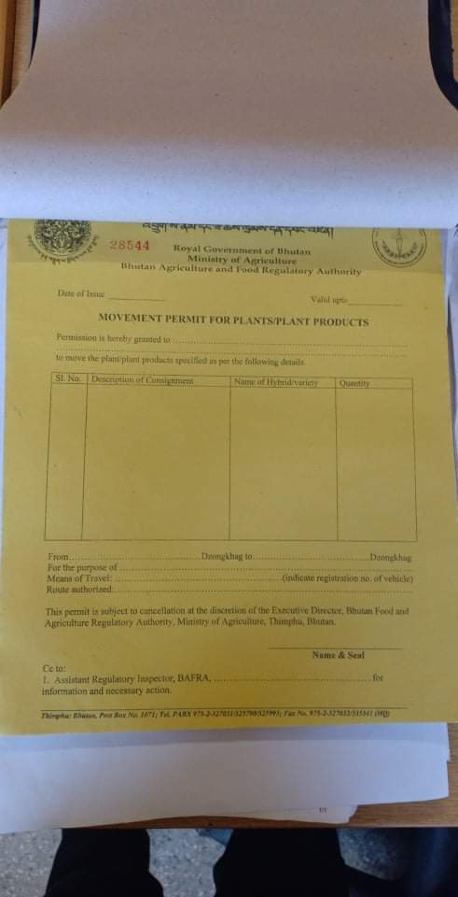

Annexure 17- Movement Permit for Live Animal

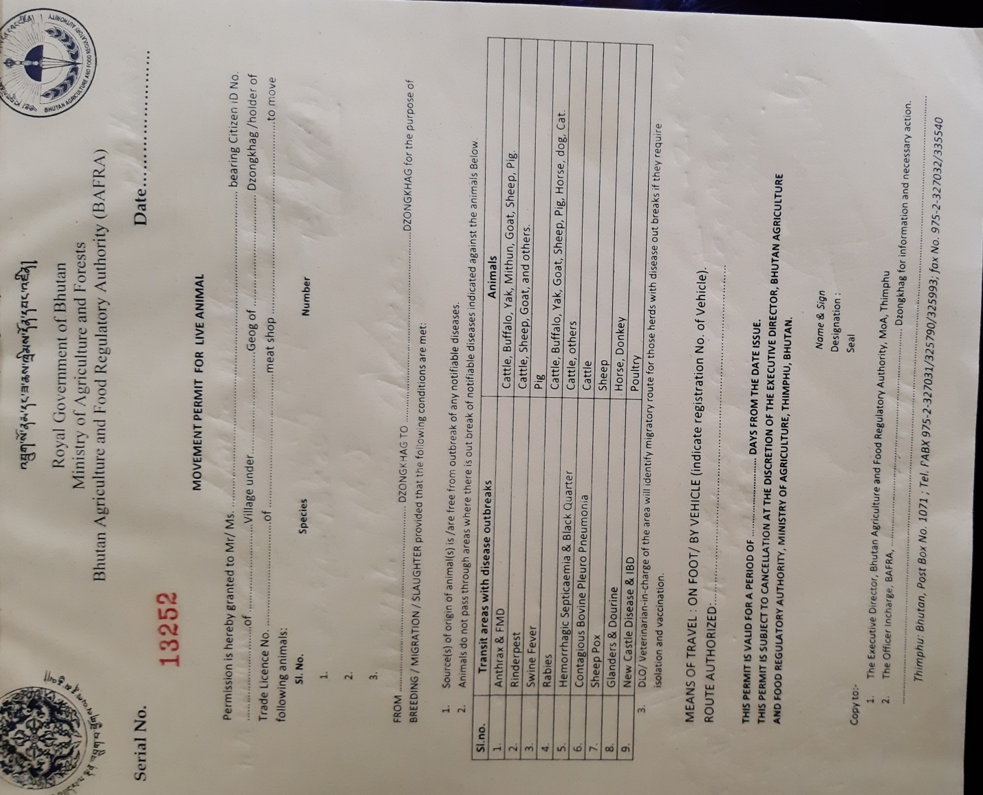

Annexure 18-Movement Permit for Livestock Products

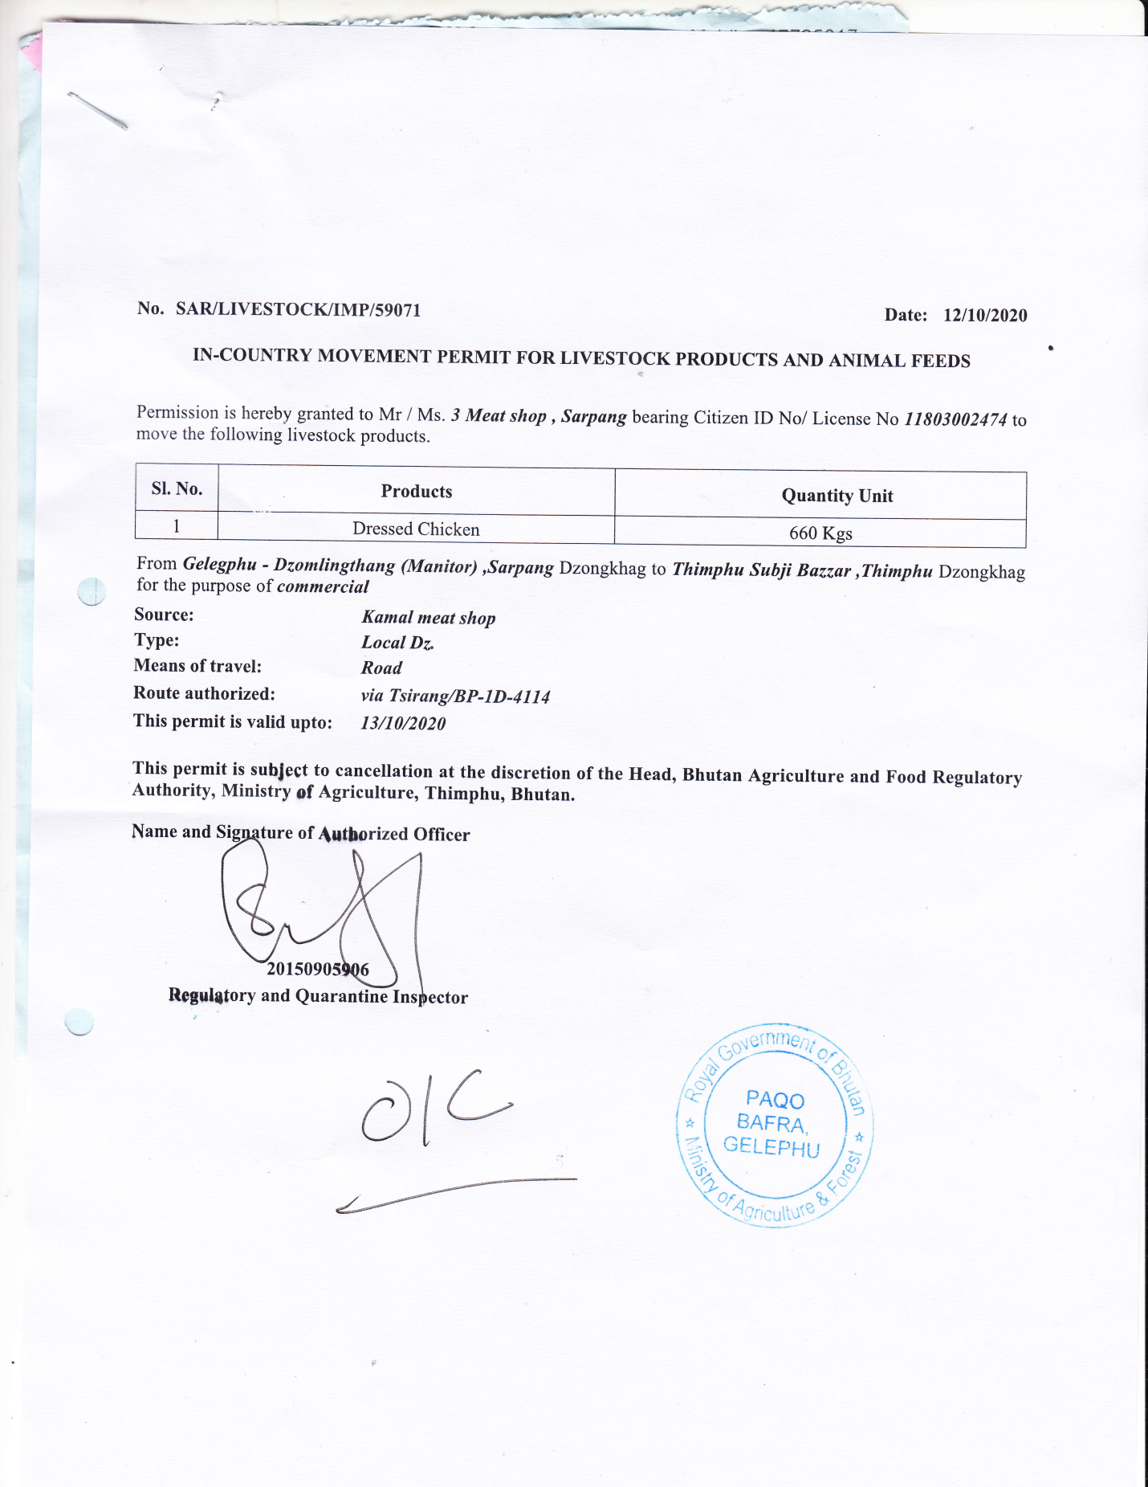

Annexure 20- Food Handlers License

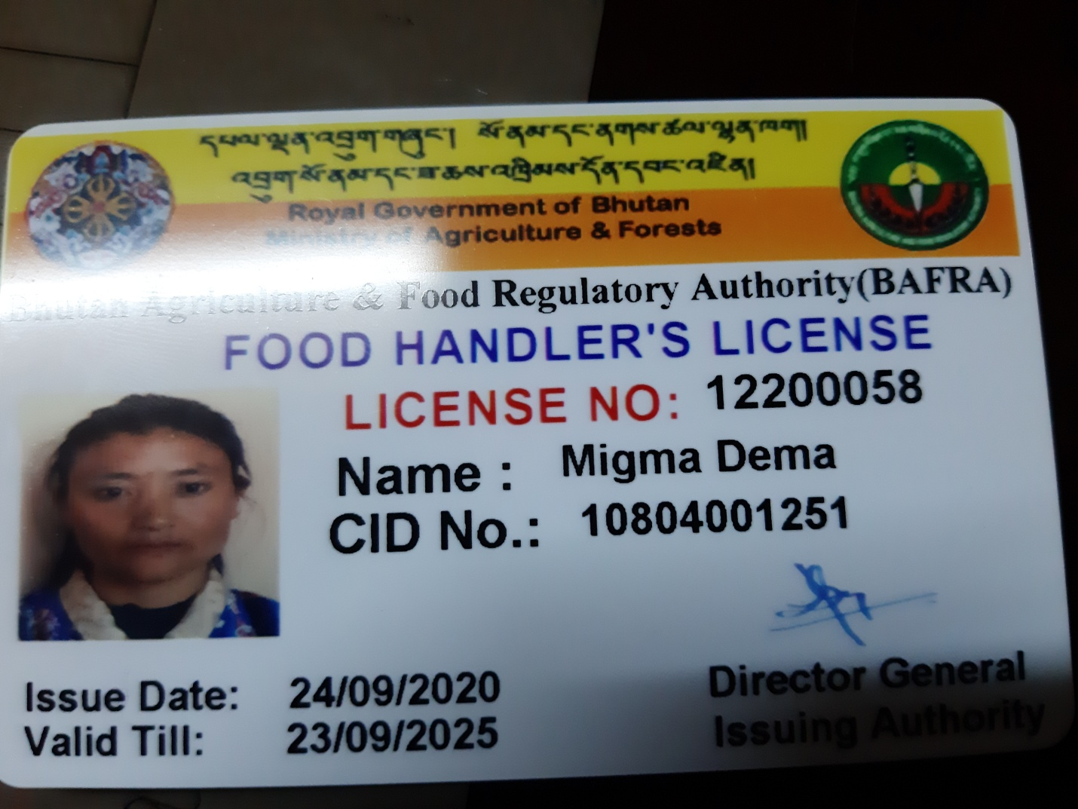

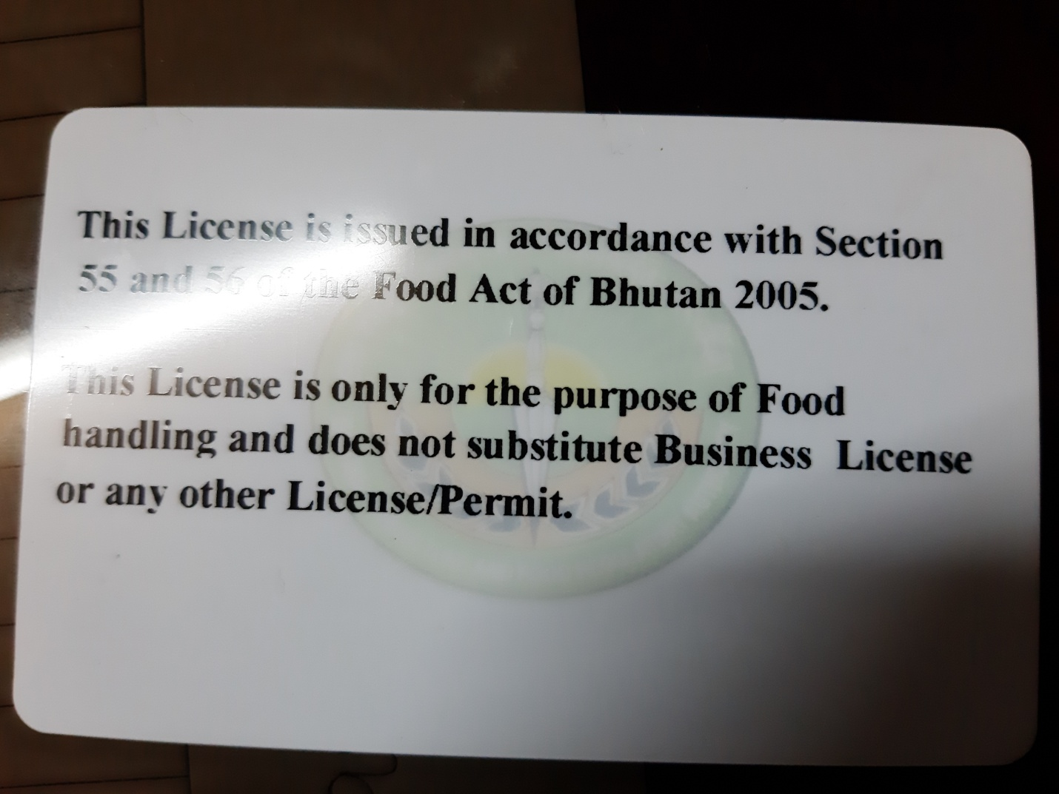

Annexure 22- Complaint acknowledgement

To:

(Name and address of Complainant)

Subject: **COMPLAINT ACKNOWLEDGEMENT**

Dear Sir/Madam,

This has reference to your letter No._________________ dated _______________ regarding your complaint on___________________________________________________________.

Your complaint has since been registered and Complaint registration number is ___________ and date of registration is _____________. Kindly quote this complaint registration number in all your future correspondence with us.

We will inform you of the outcome of the complaint as soon as investigation is over.

Thanking you,

Yours Sincerely,

Certification Manager

Annexure 23- **CLOSURE OF COMPLAINT**

To (Name and address of Complainant)

Subject: **INFORMING CLOSURE OF COMPLAINT**

Dear Sir/Madam(s),

This has reference to your complaint registered with us (Registration No.________________ dated________________)

The decision regarding the complaint was communicated to you vide ref.__________________ dated_____________by our Management Systems Department.

Subsequently you have informed us vide your letter No._______dated_____________that you are satisfied with the decision taken and agreed to treat the complaint as closed.

Therefore we are closing your above complaint. We thank you for your cooperation and look forward to your suggestions for the improvement of our Product Certification Scheme.

Thank you,

Yours faithfully,